**End to End AWS Data Engineering Project**

**Data Pipeline design:**

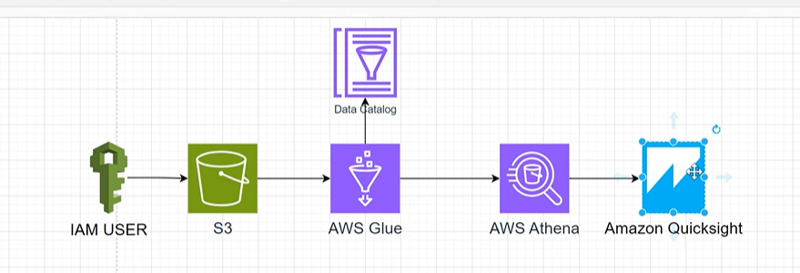

IAM (identity and access management) where you can create users, groups, policies etc.

**Creating a user:**

Click on create user

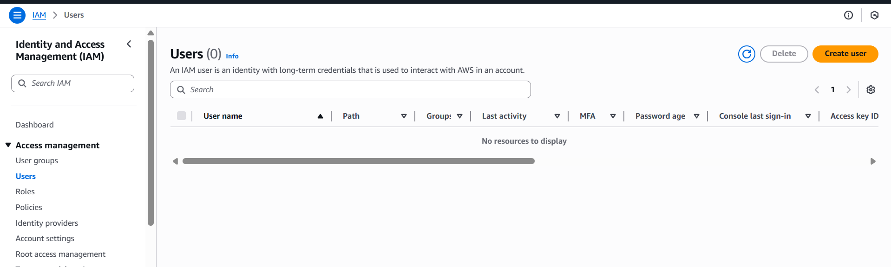

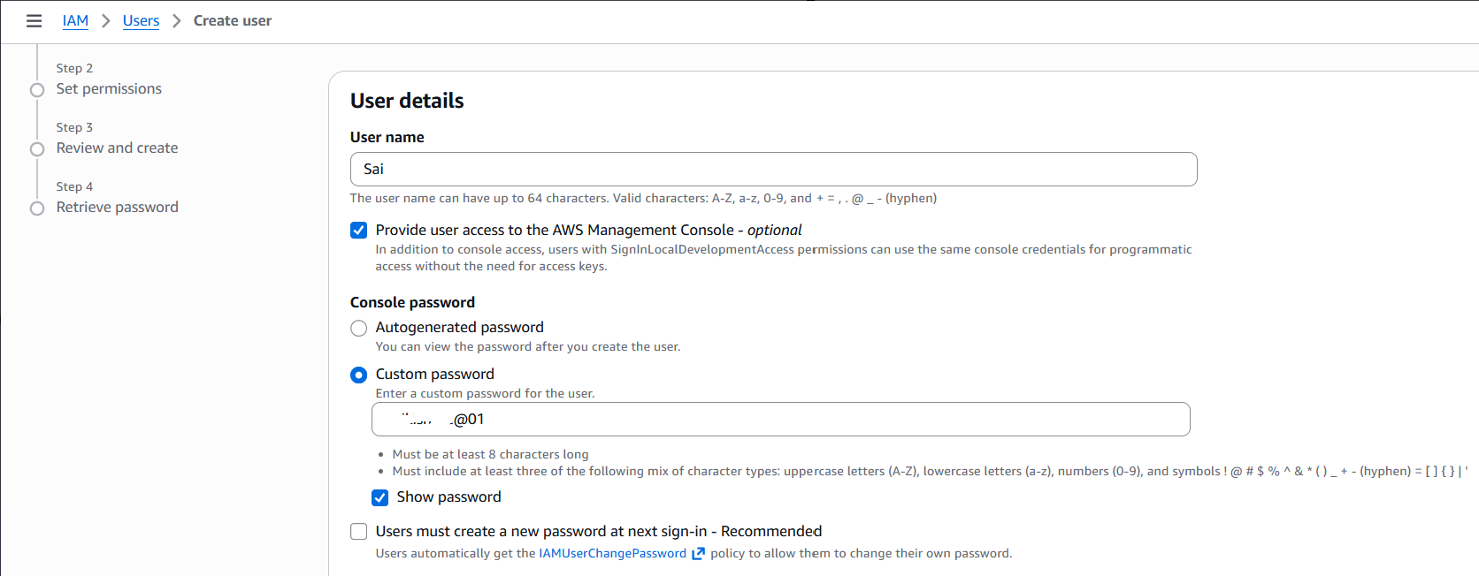

Click next

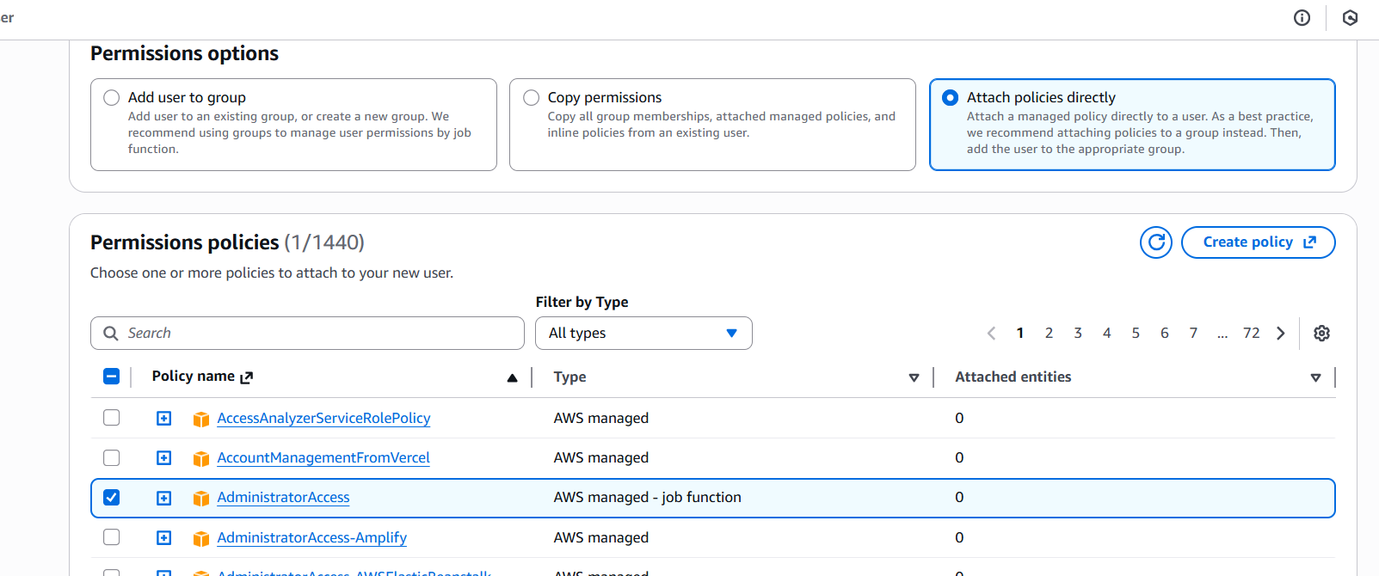

The above implies the user (sai) get all the admin access

Click on next

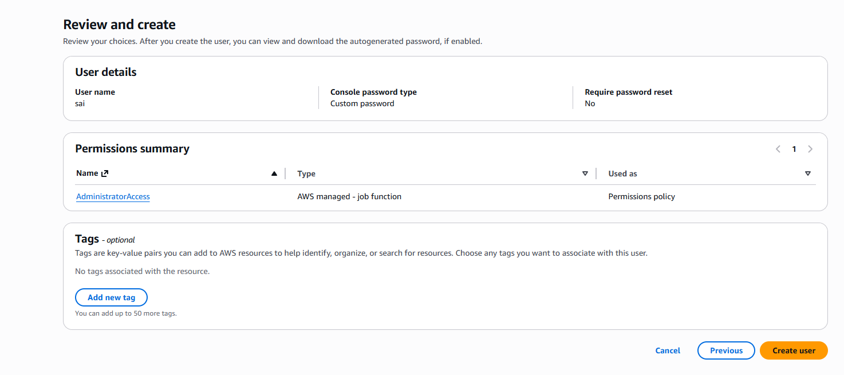

Click create user

U see the interface as shown:

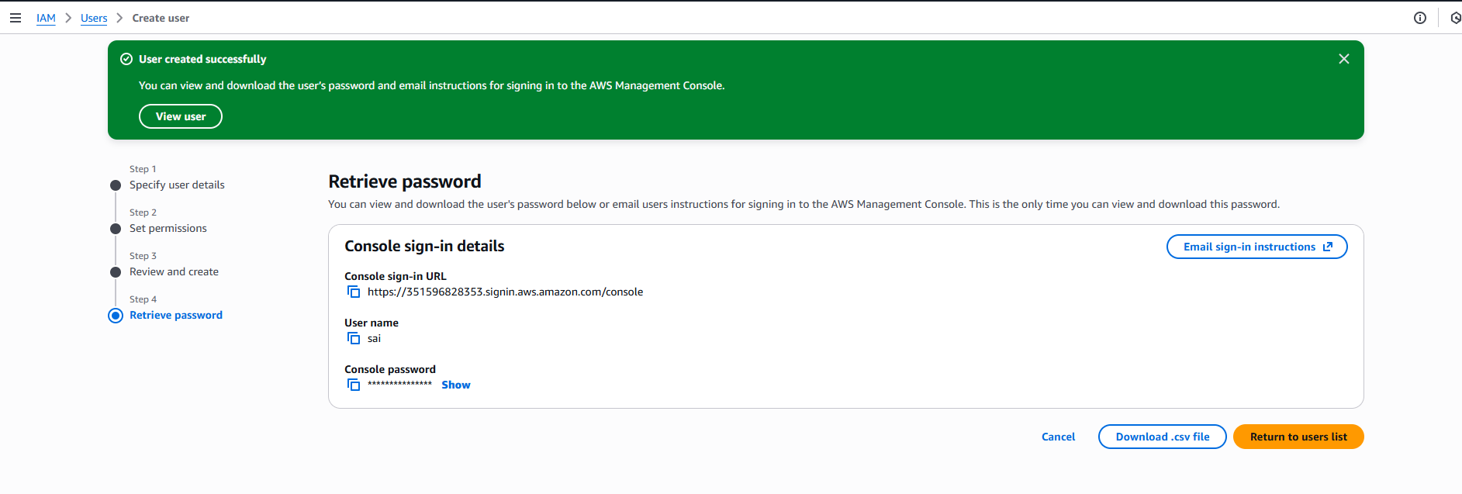

Now click return to users list

Log out and login as a IAM user

Before logging out, copy ur account ID: 351596828353

Click on sign out

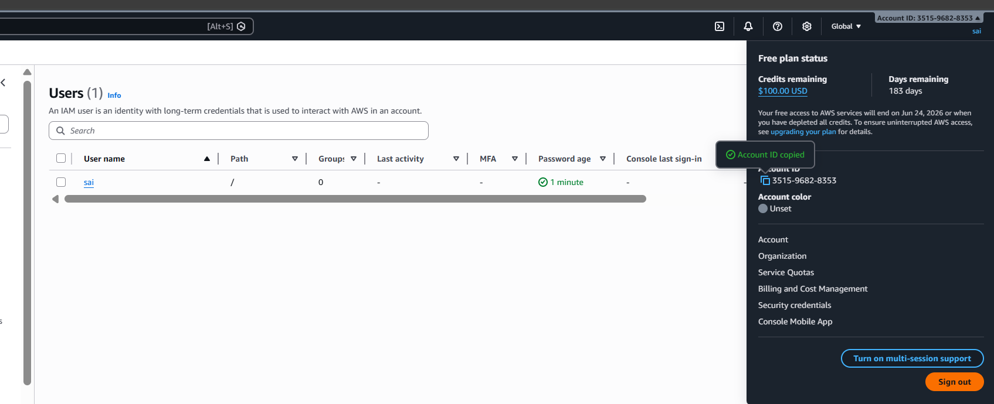

Logging as IAM user

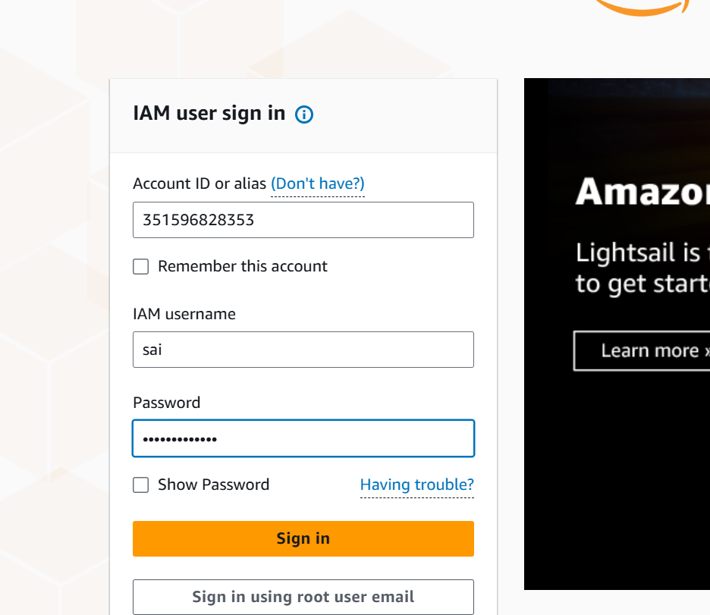

The interface looks like this and now click on s3 to create my bucket

S3 is a kind of cloud storage where u can store all kinds of files like structured, unstructured etc

Let us create a bucket

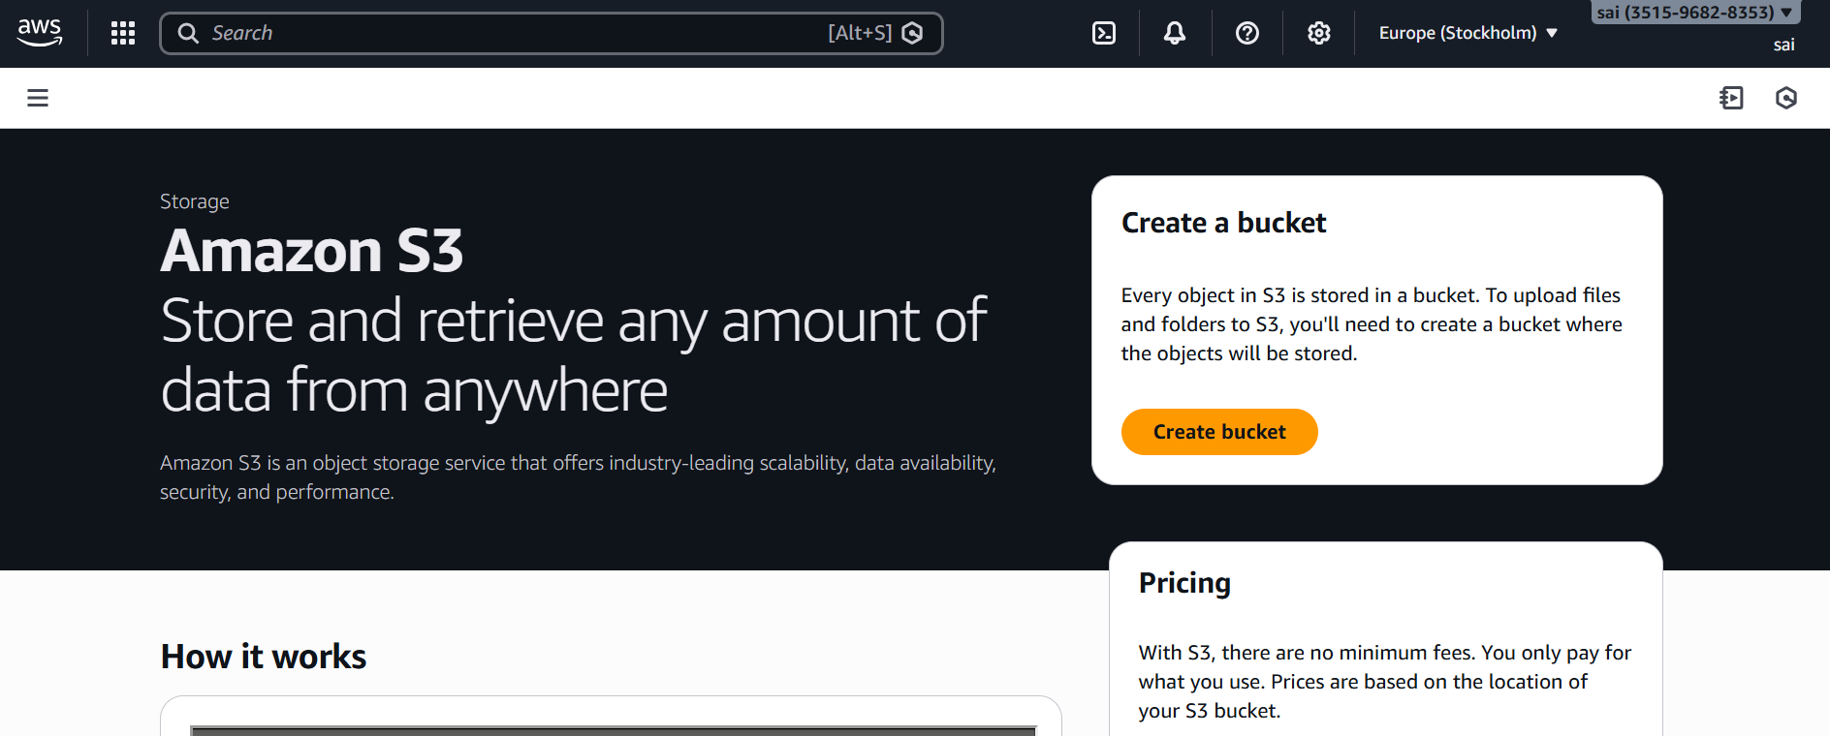

Before that changed the region as follows, click on setting button below beside the name

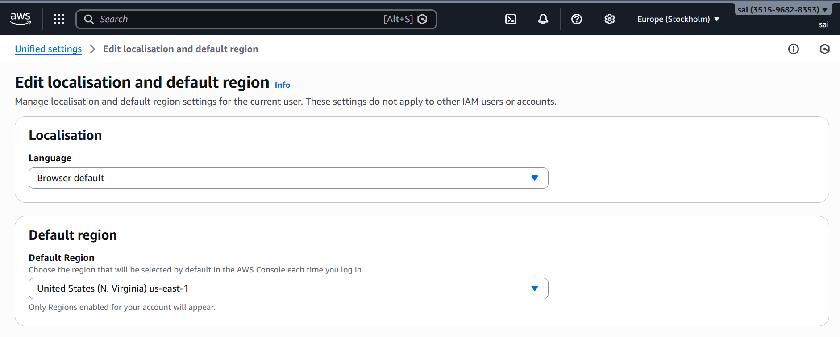

If u give the bucket name as test, as it is a name globally.so give a name which is unique globally

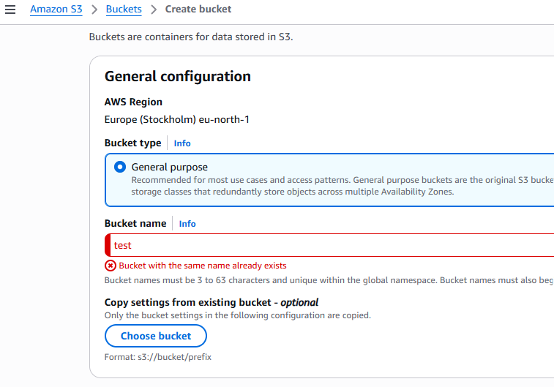

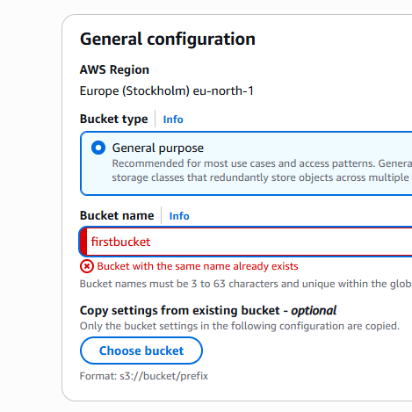

Keep all the default settings, I have given bucket name as ‘sai01project01’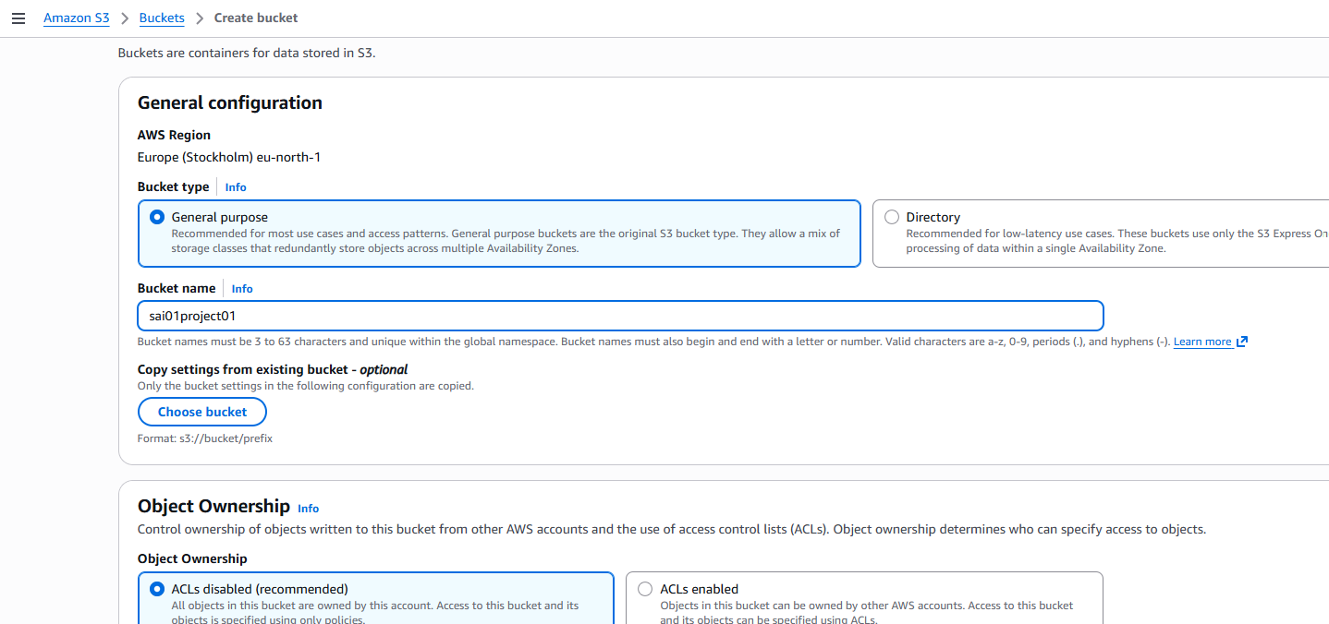

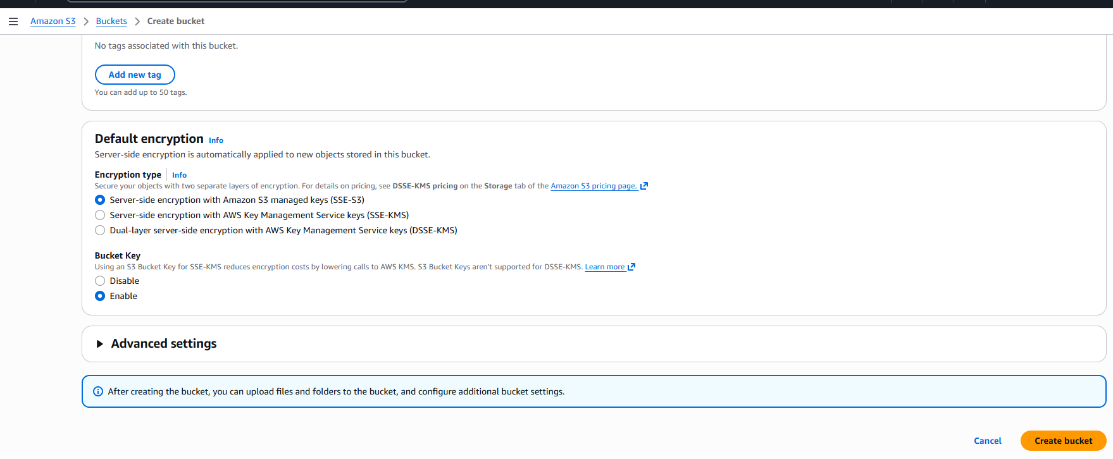

Click create bucket

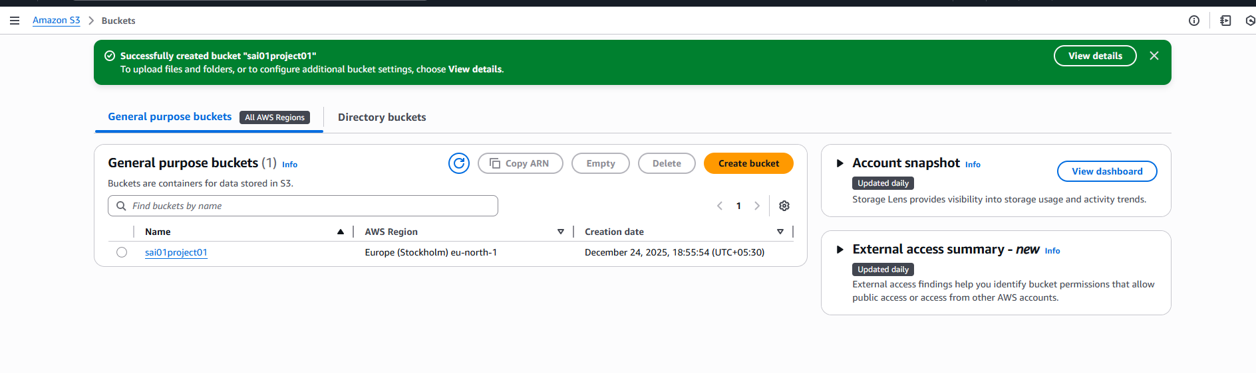

Click on it

Create a folder in it

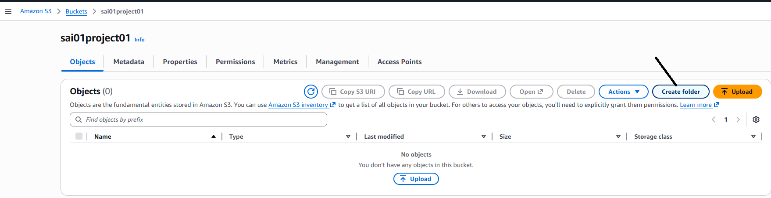

Create folder as shown

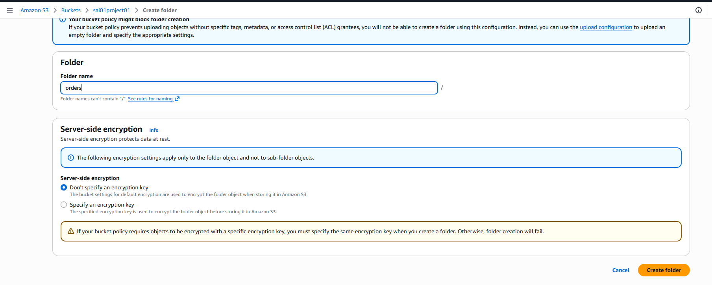

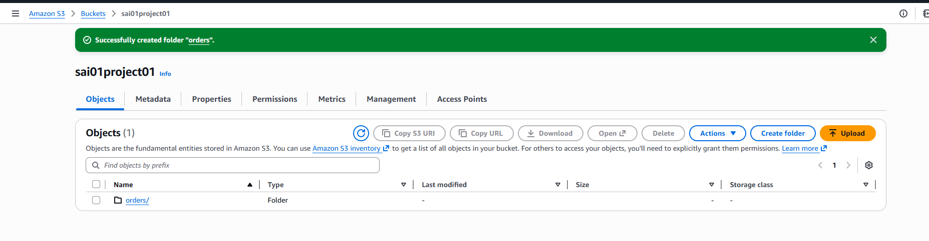

Lets download the Kaggle data  
<https://www.kaggle.com/datasets/vivek468/superstore-dataset-final?resource=download>

Open the excel, filter ‘order date’ with jan 1st 2017, copy and paste in notepad, save

The data looks like this

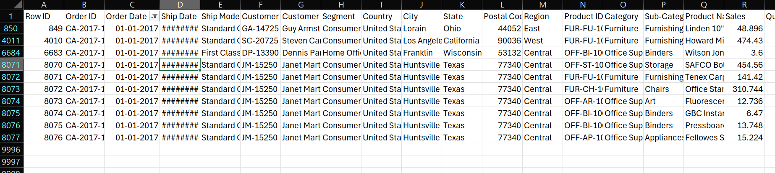

Again creating a folder in orders

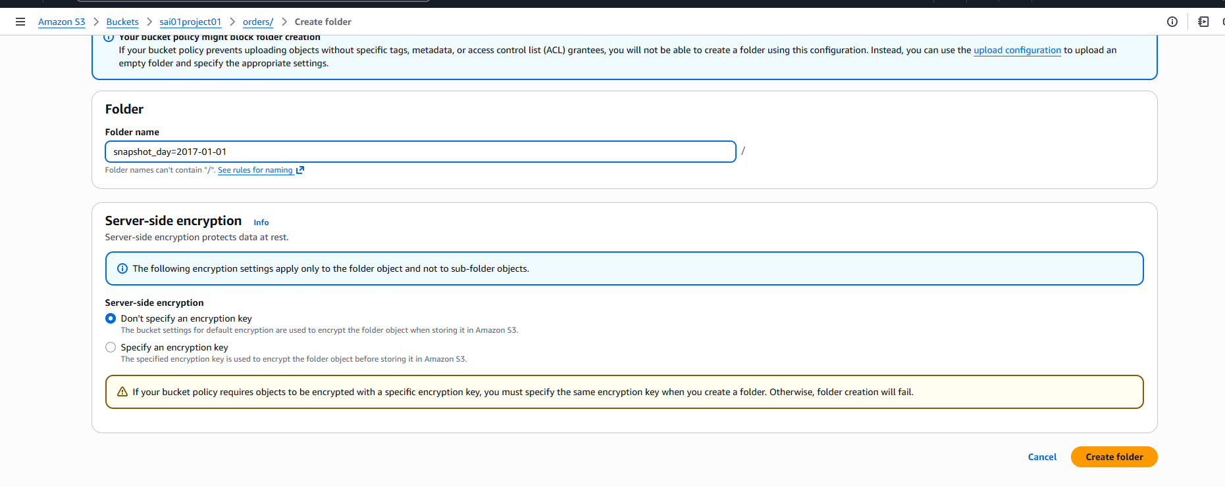

When we create AWS crawler, when we create the structure of the folder with the name like this, there is a partition with all of this, we can discuss later

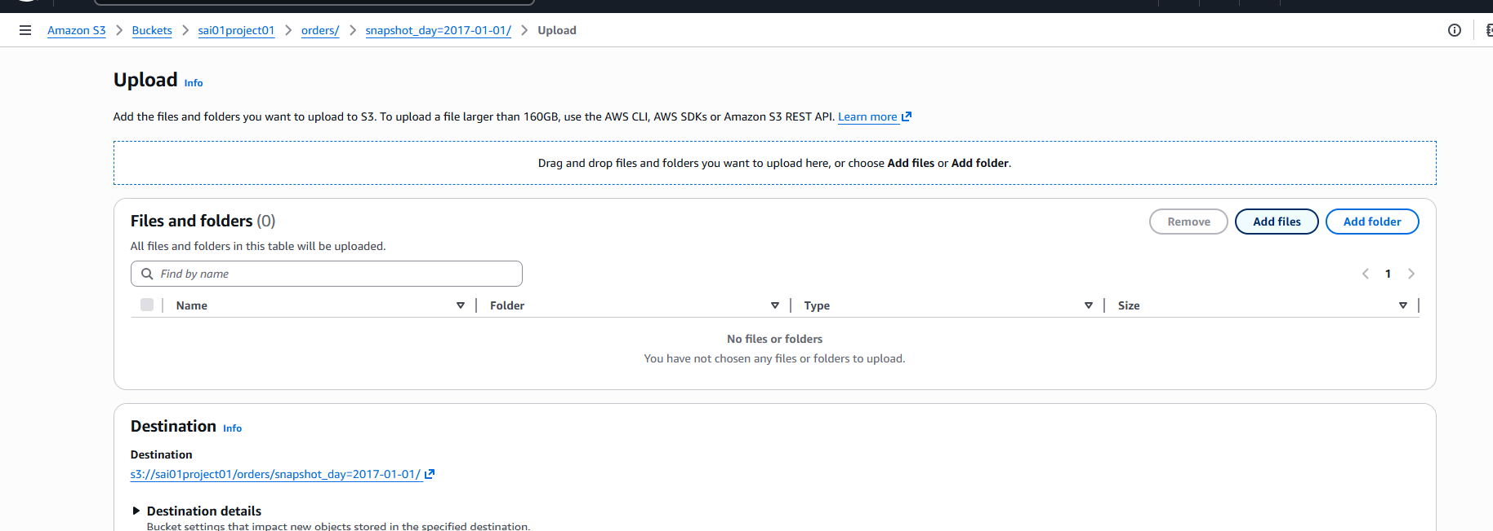

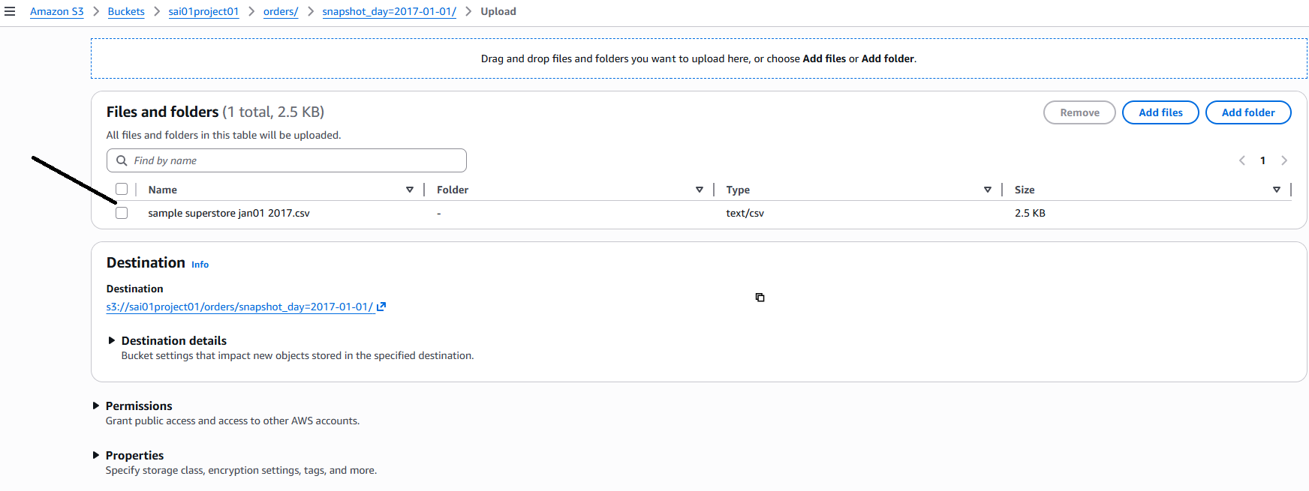

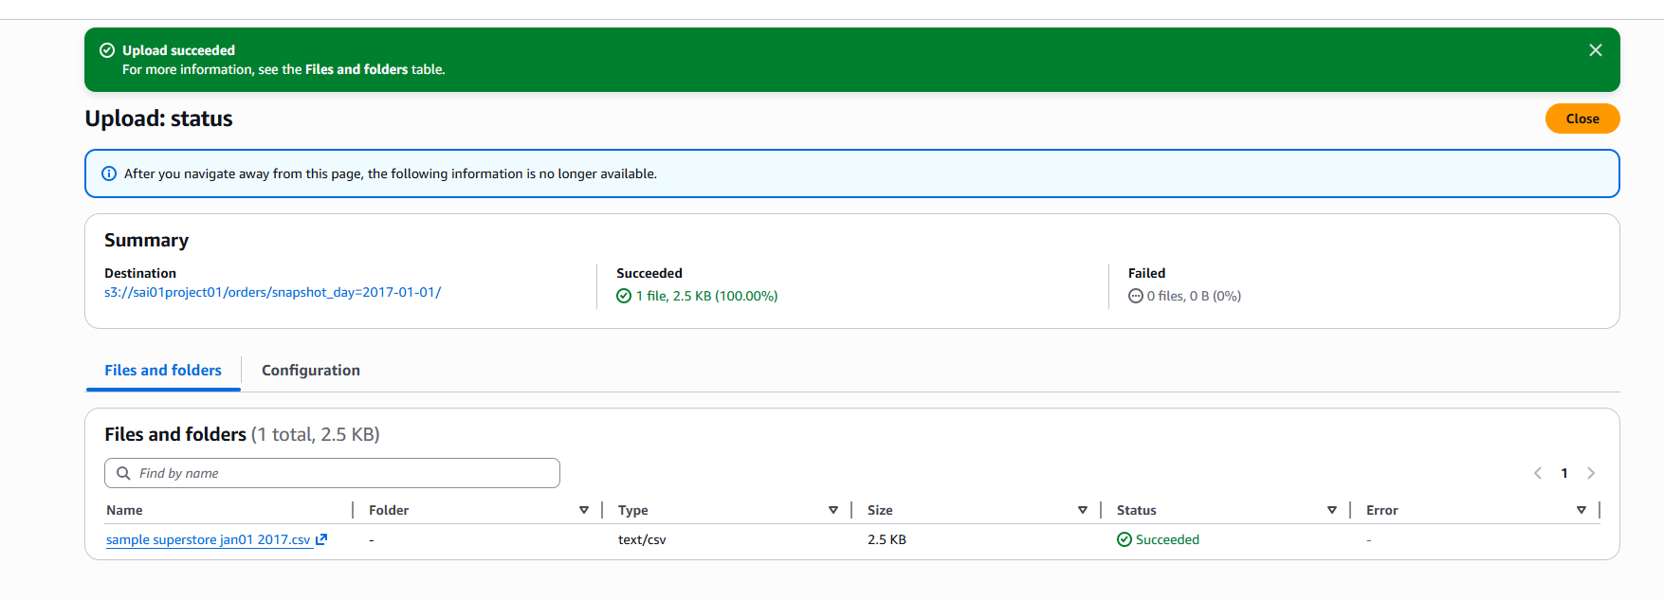

Now let us create AWS crawler

Search glue

Glue is an ETL tool and u can run also crawler and create a data catalog using glue

Here is the GLUE interface

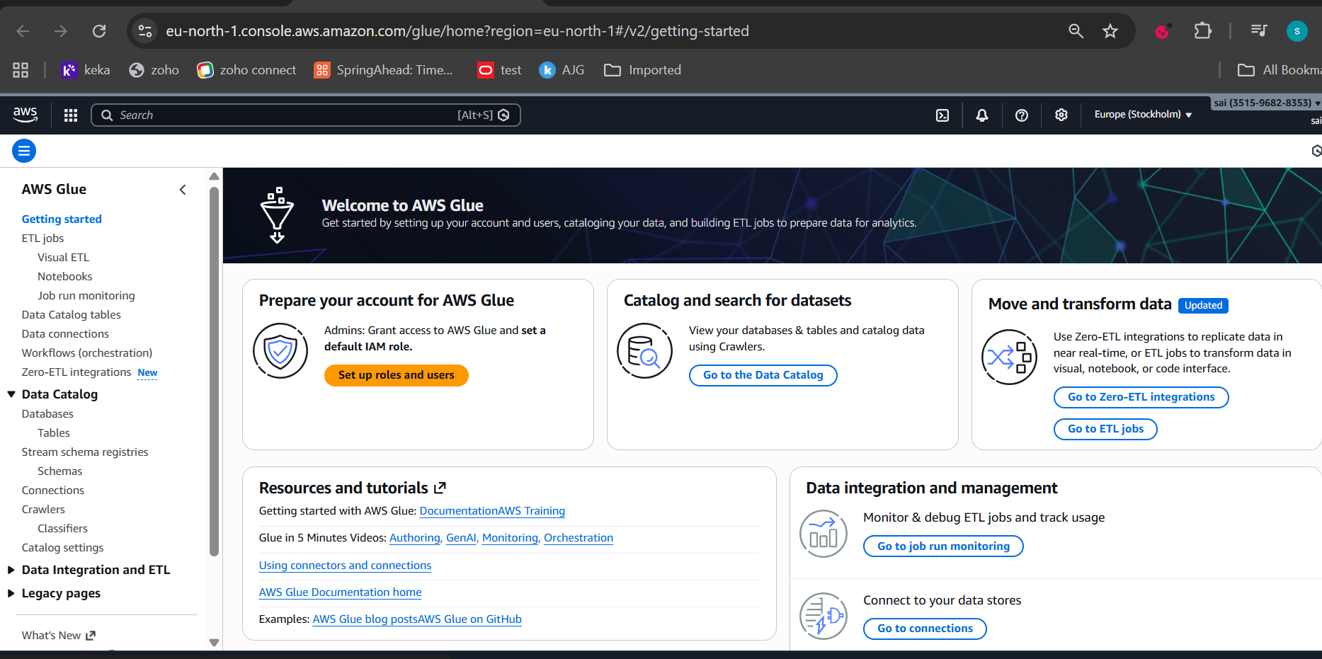

We are going into crawler and data cateloging

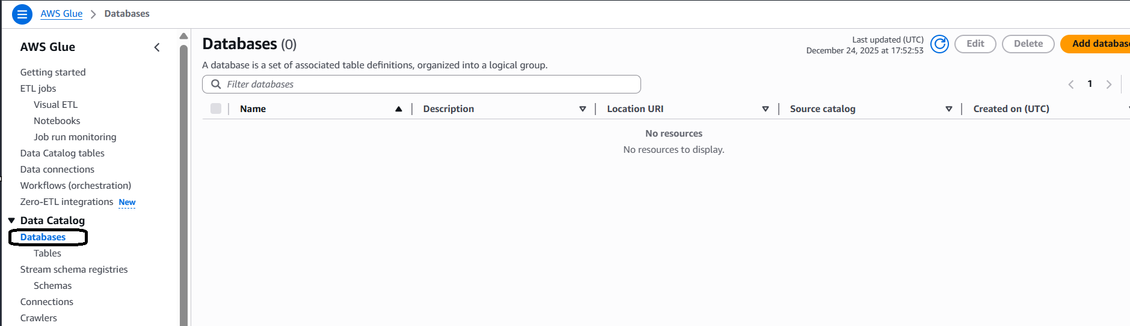

Click on add data base ,give name and click create database

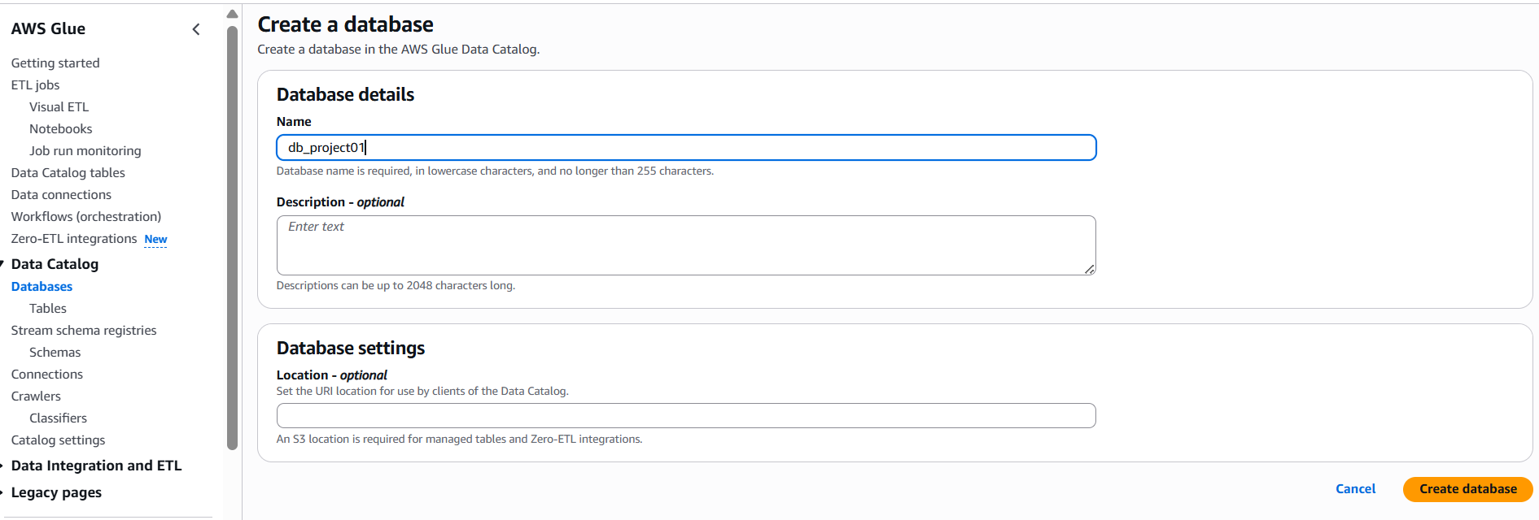

Click on crawlers, create crawler

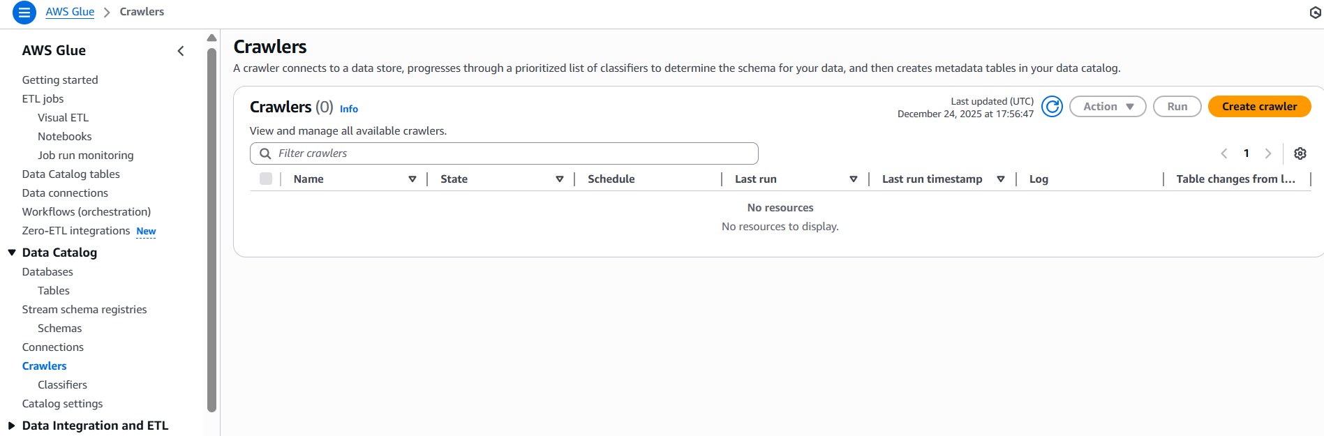

Give name and next

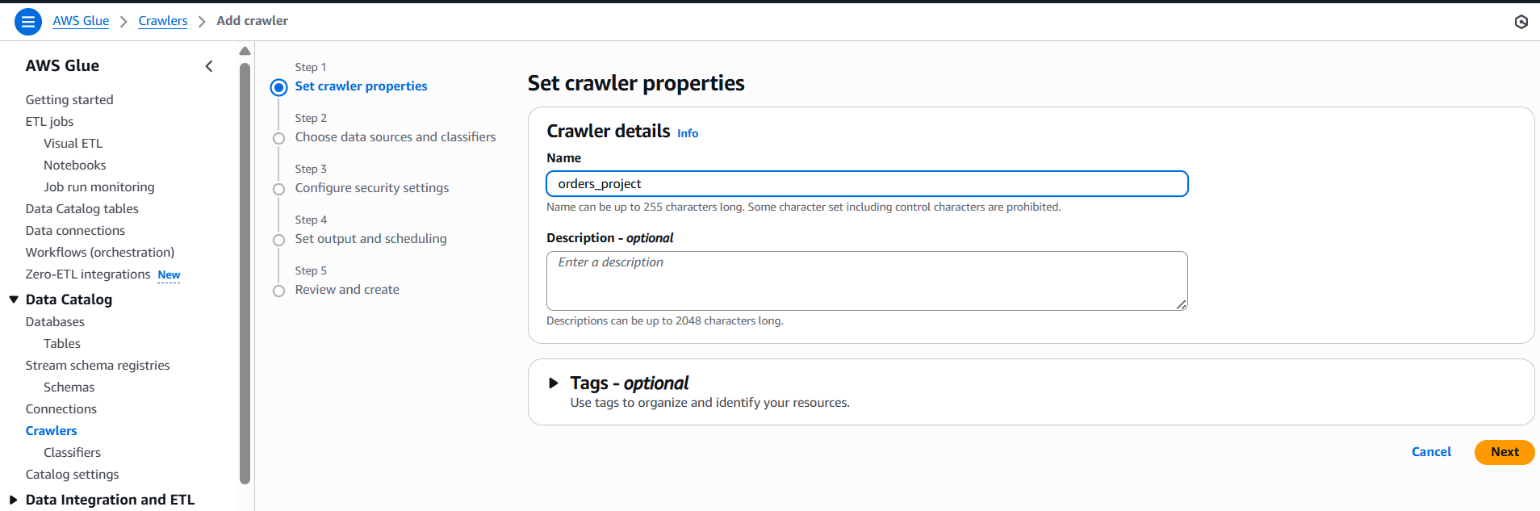

Click Add datasource

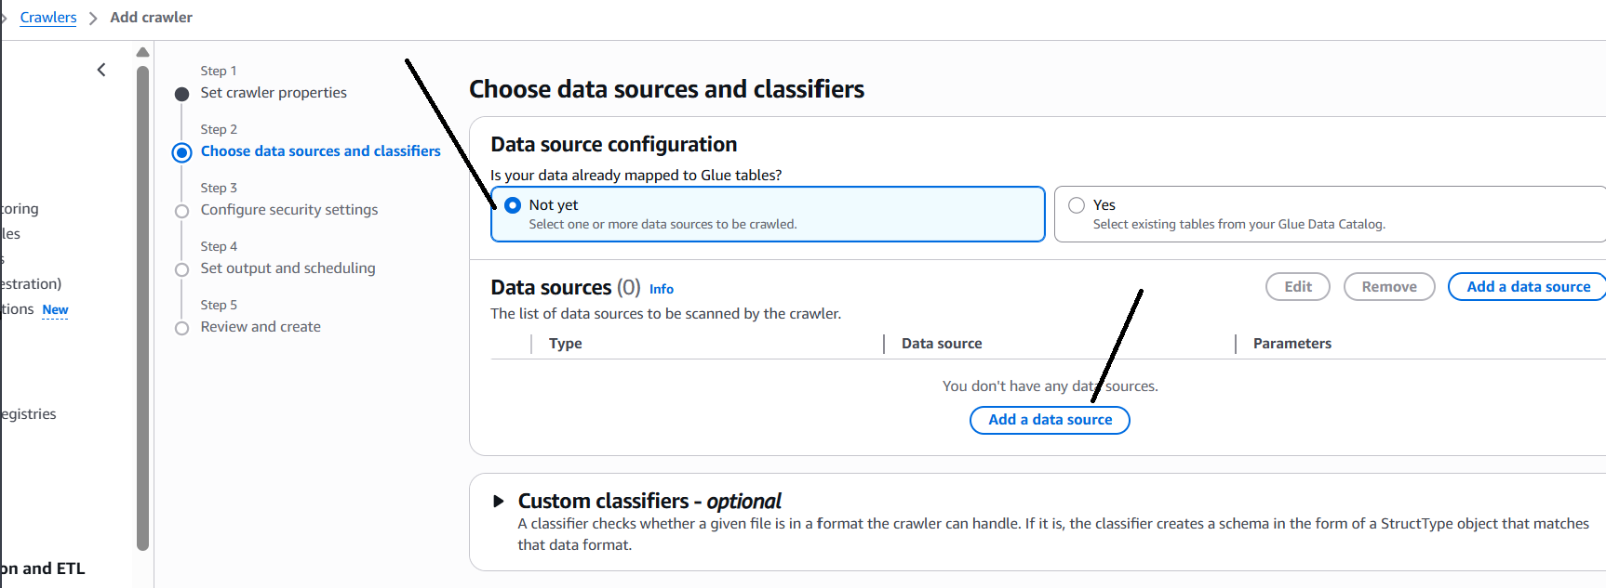

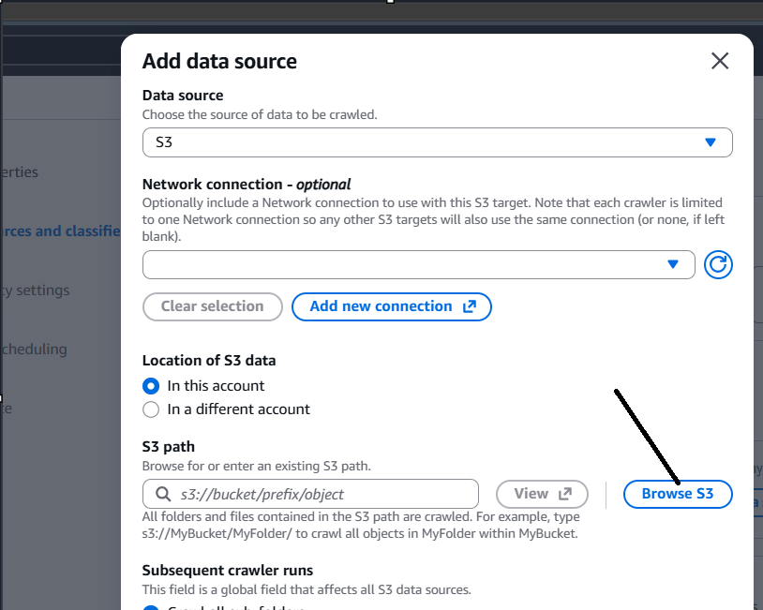

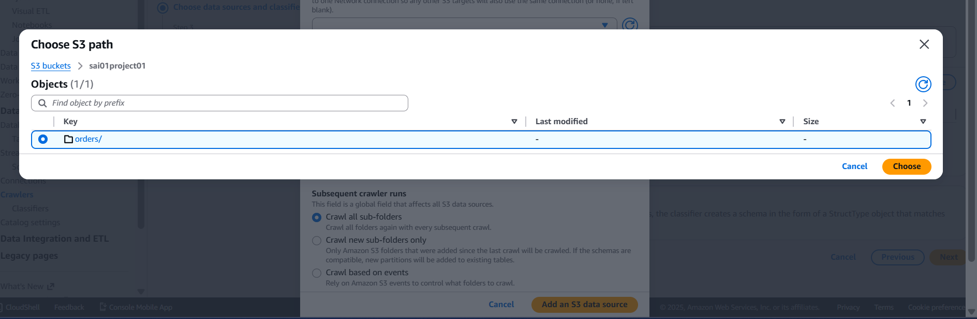

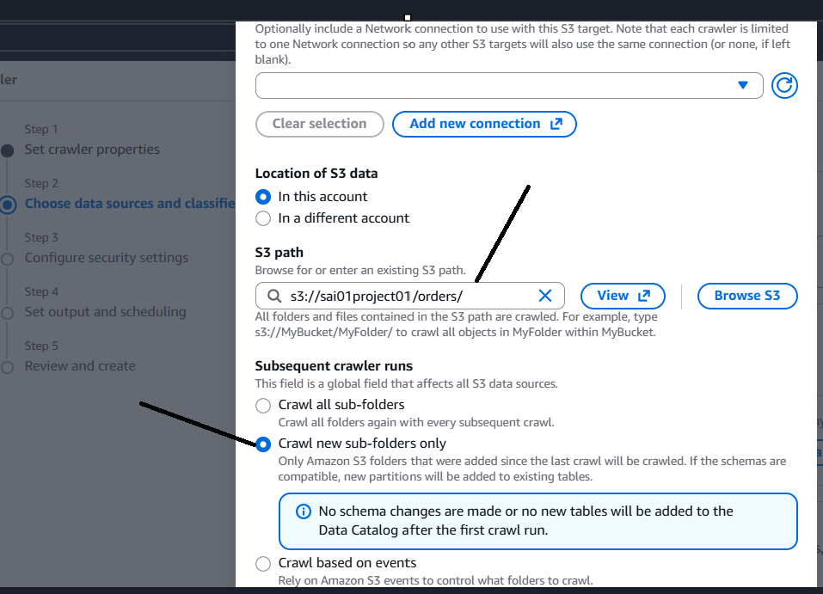

Click add an s3 datasource

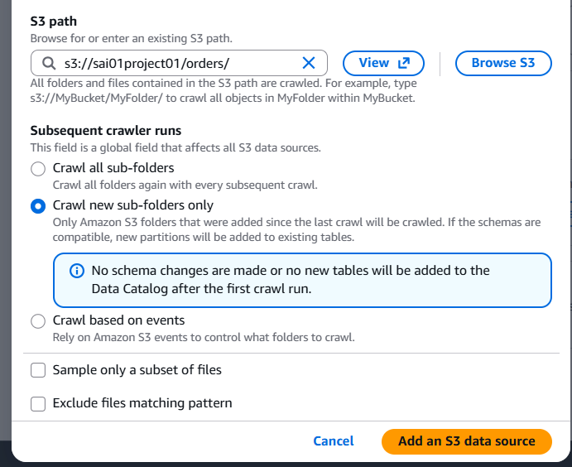

The above meaning is the folders which were crawled will not be crawled after addition of new files

Click next

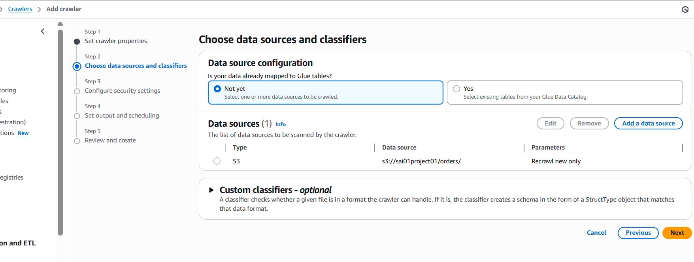

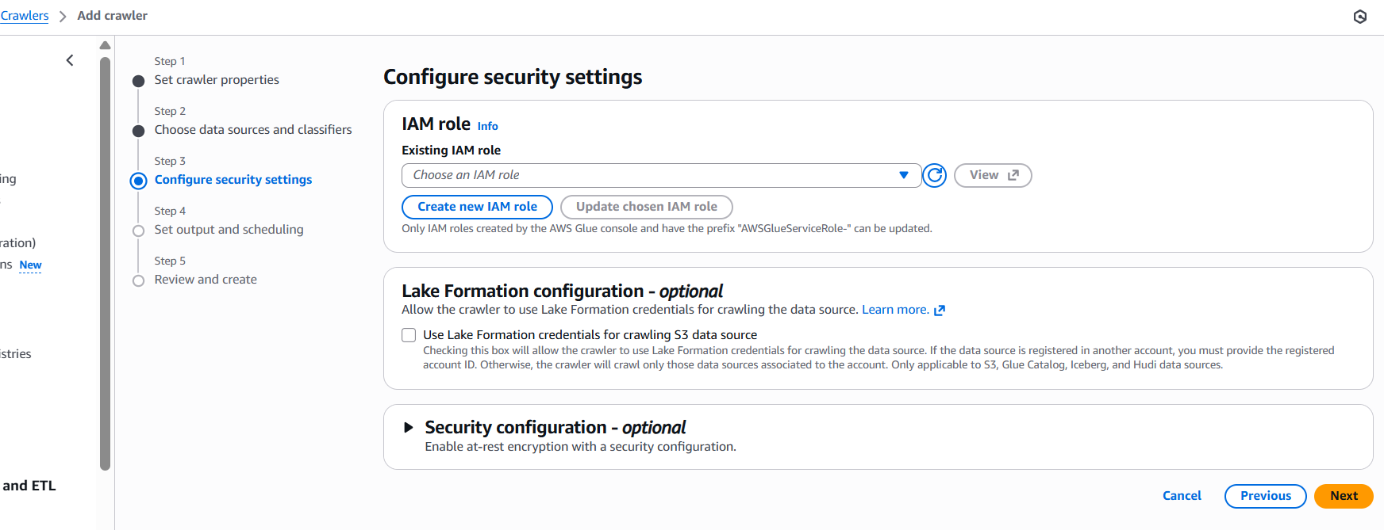

We have created IAM user and user logged in and using AWS services. similarly for AWS services to work they need some access . so, IAM role is used to give different services access.

As I Want to run the AWS crawler job, I have to use an IAM role for that using which role I want to run the services and to that role I have to give all the access which it needs.

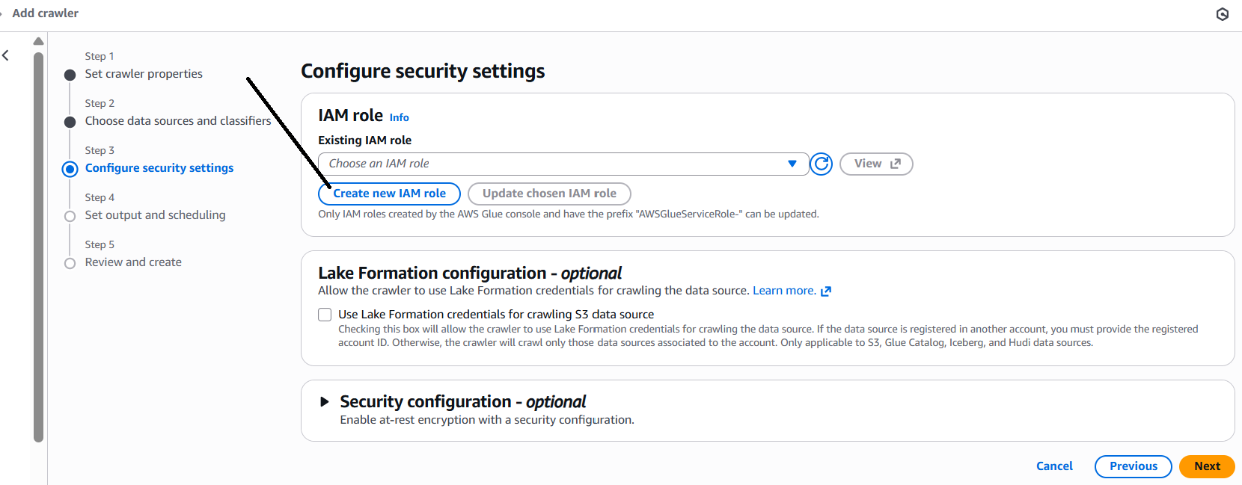

Project01 is the name and AWSGlueServiceRole is by default available

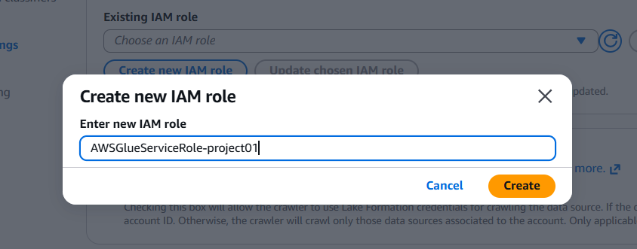

We had created IAM role as shown, click on view to see

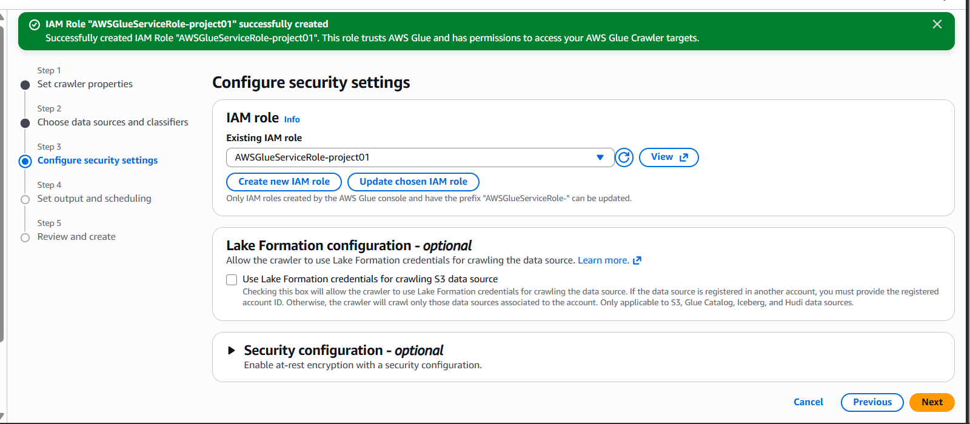

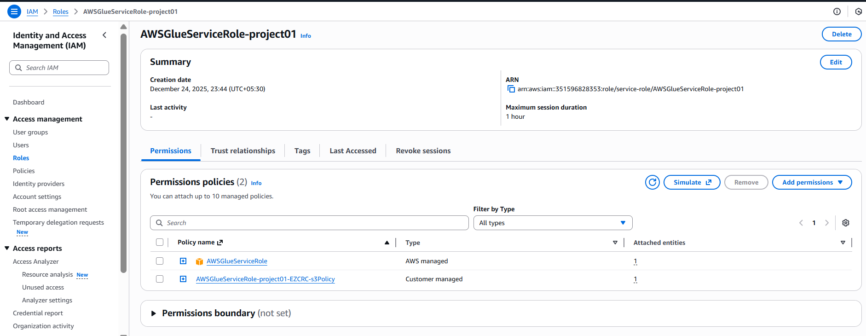

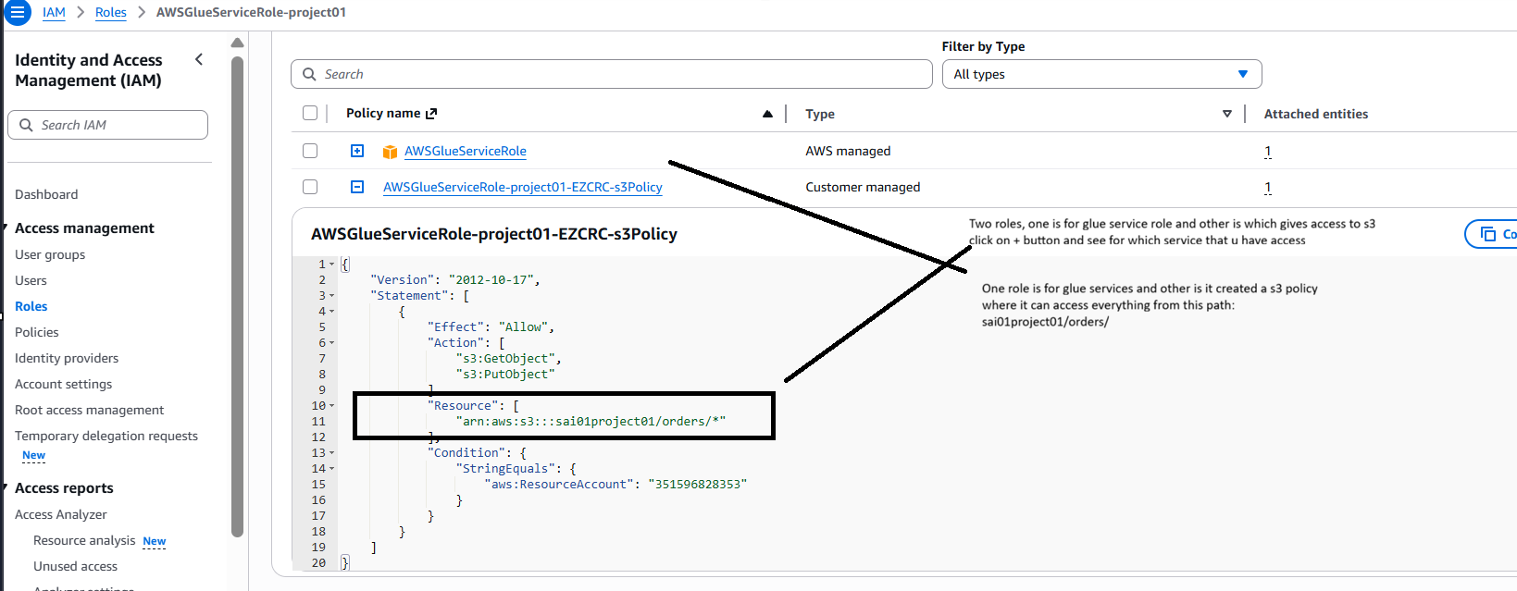

As we have given data source as S3 path, it has automatically taken the access to that s3 path by creating a policy

Click next

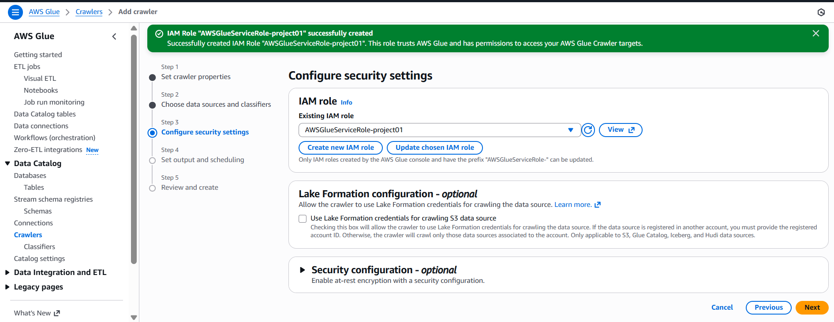

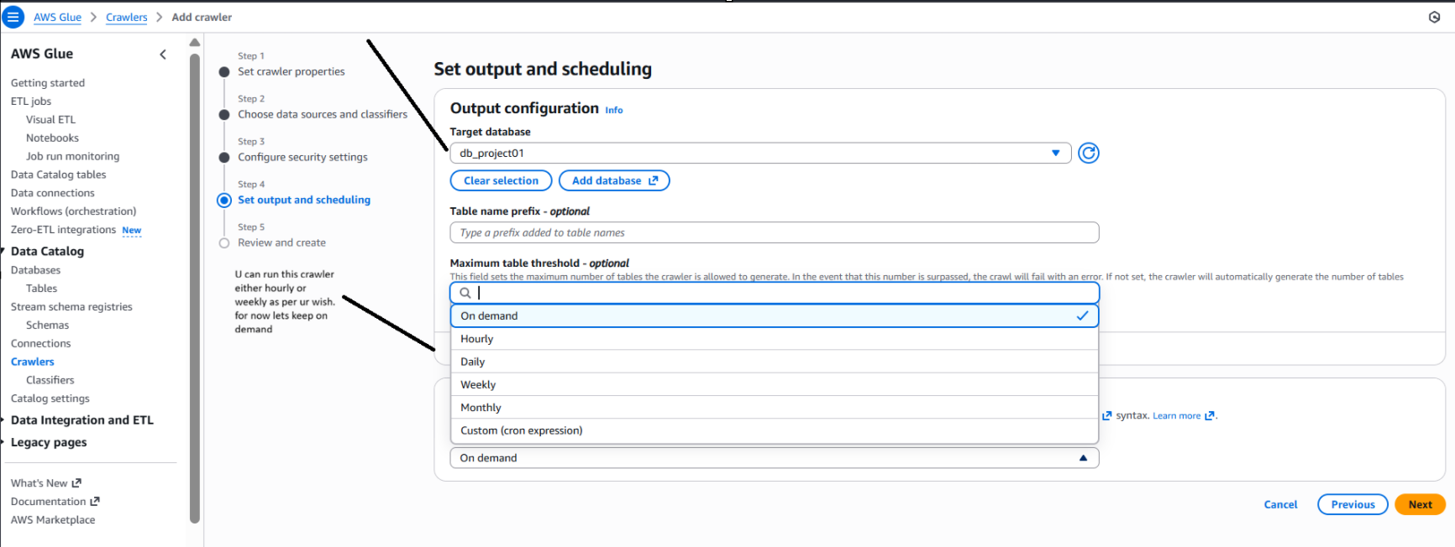

Click on next

Create crawler

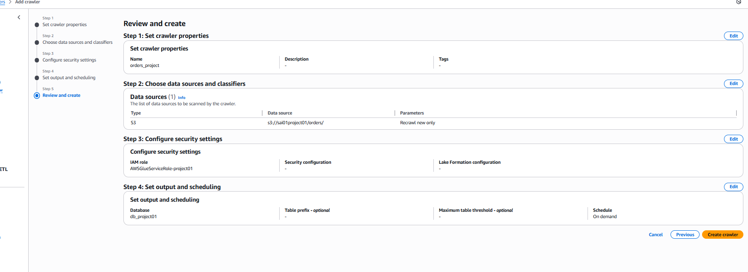

Here is the interface

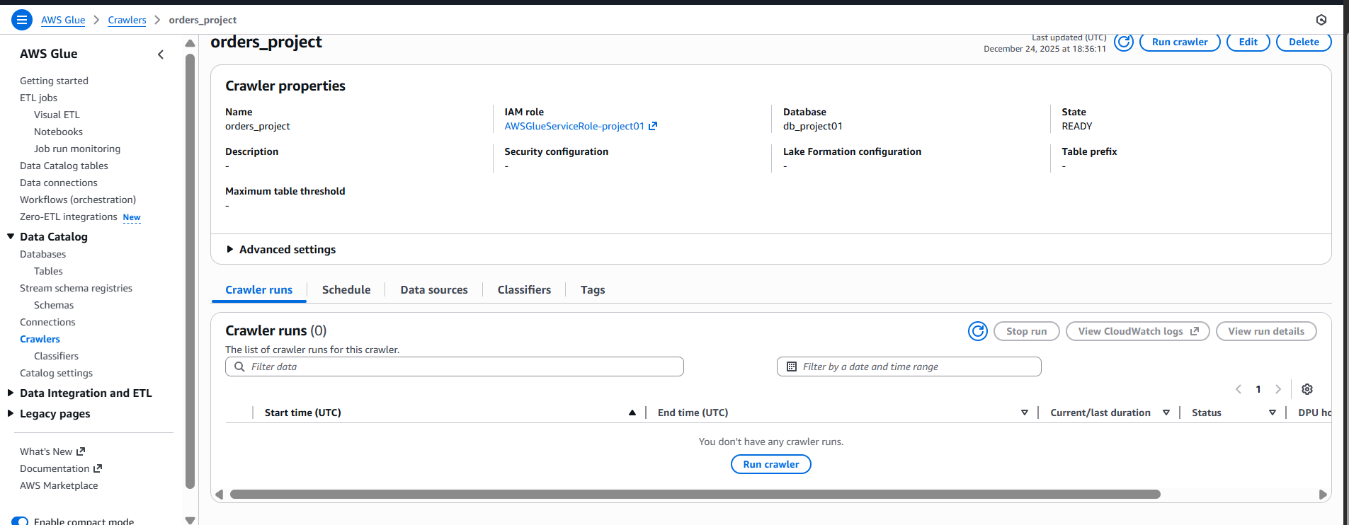

Click on run crawler

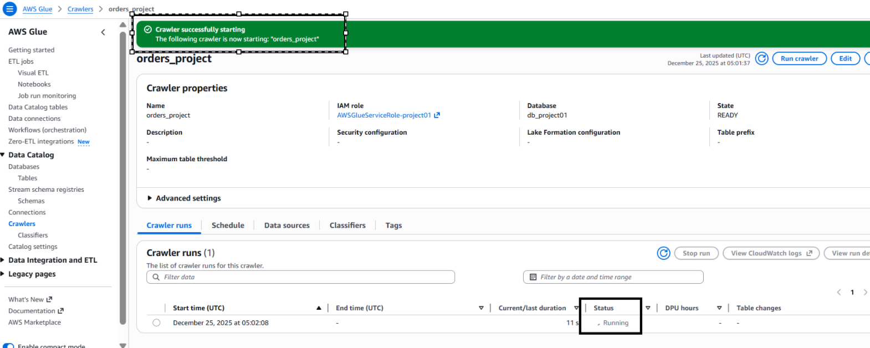

Working of crawler…

As our data is in s3 which is a file, if u want to query this data u need to have information about data which is meta data like what are the columns, datatypes etc.Then only I can query the data using sql.

So this crawler crawls over the s3 file, identify what are the columns,delimiters etc in the file internally by itself and u will be able to see table but it doesn’t store any data in it, the data is in s3 only, it is just creating meta data

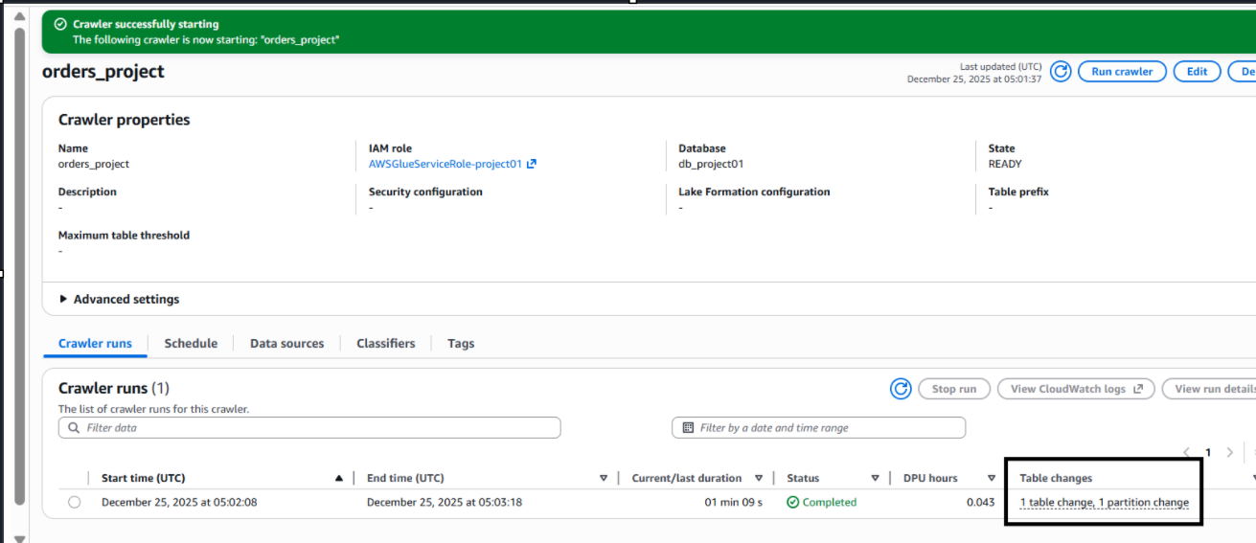

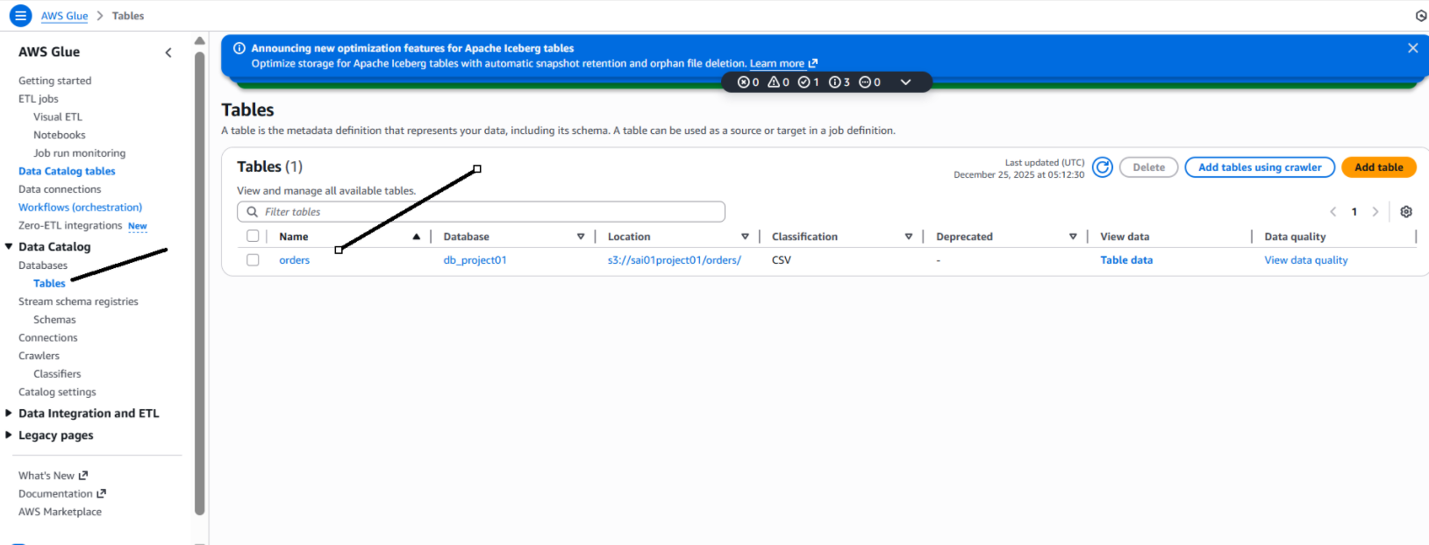

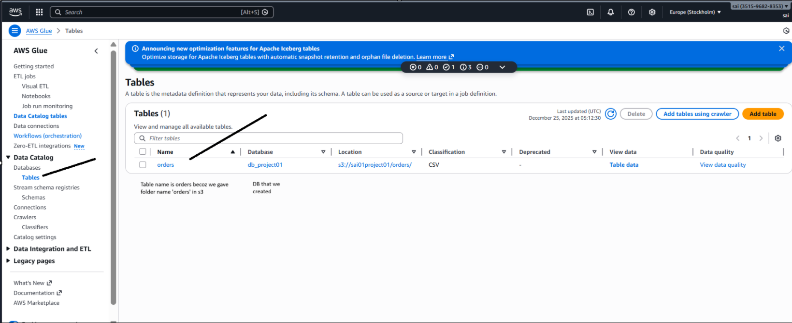

Click on the orders table, u see the meta data as shown

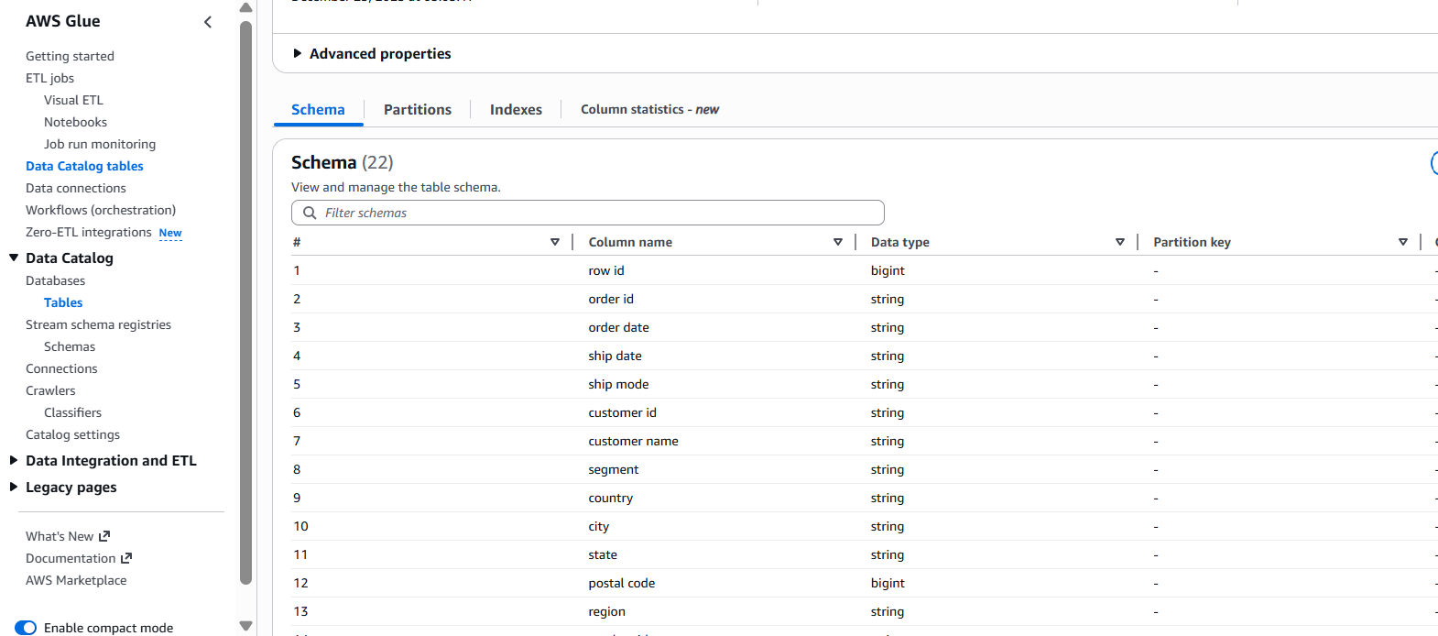

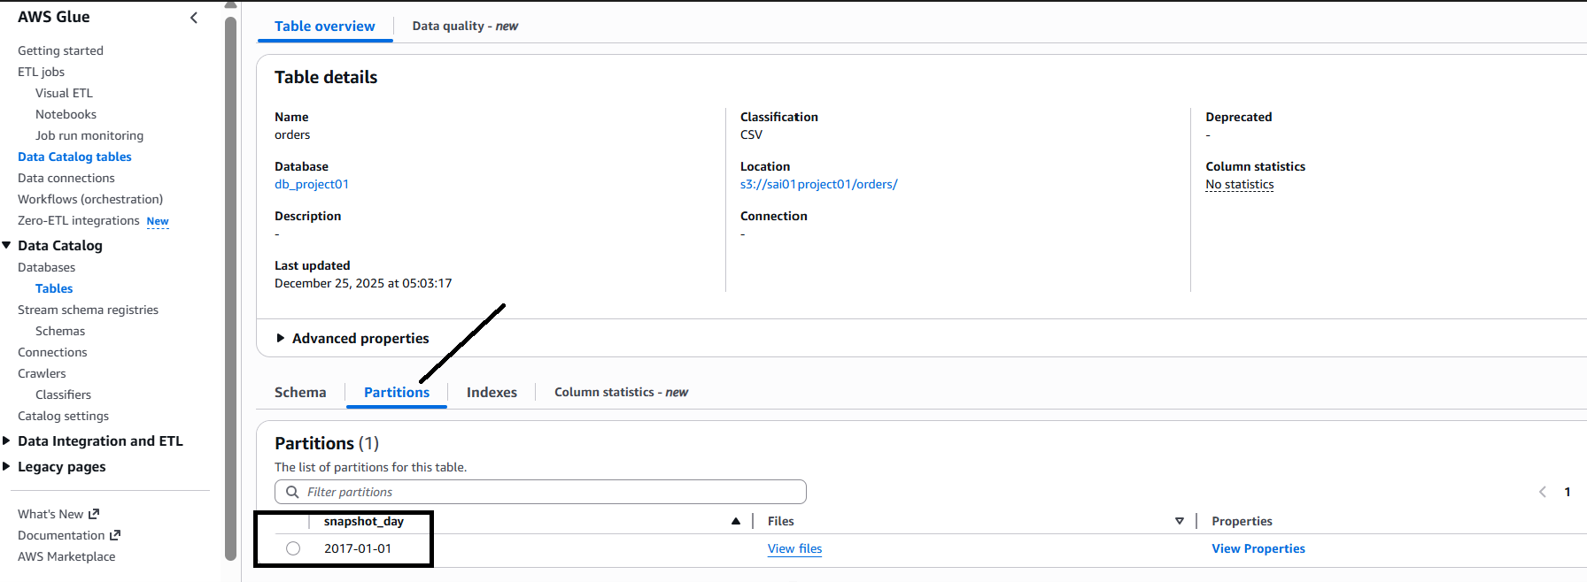

The crawler created a partition already, if I created one more folder and run the crawler again it will create another partition, these partitions will help in querying in athena

So now, if u click on view files, u see one file

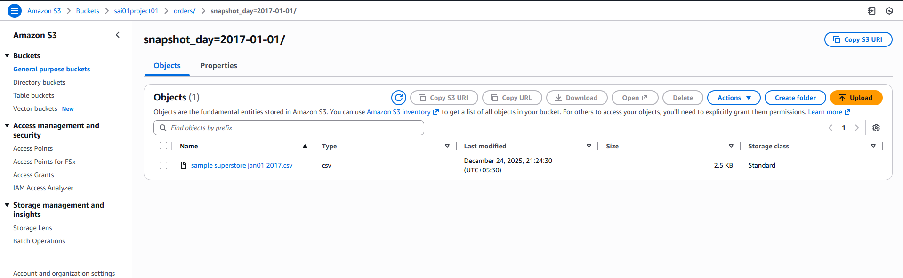

So u can click on every partition and see which s3 files are available

Let us create another folder in s3

Filtered to 4rth jan, copy in notepad, save it

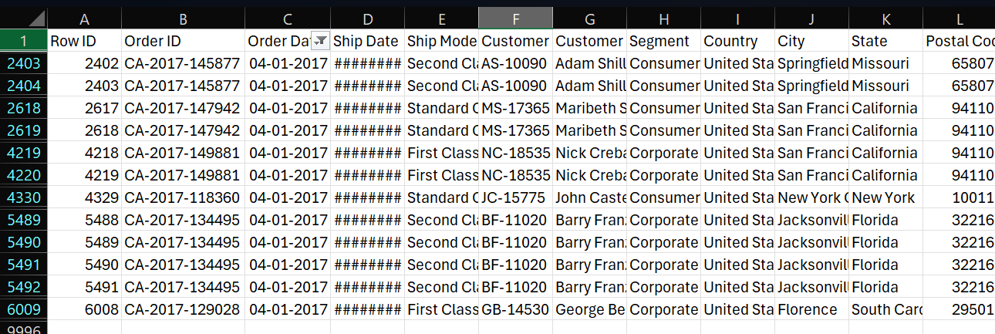

Created a folder in s3 with snapshot_day=2017-01-04

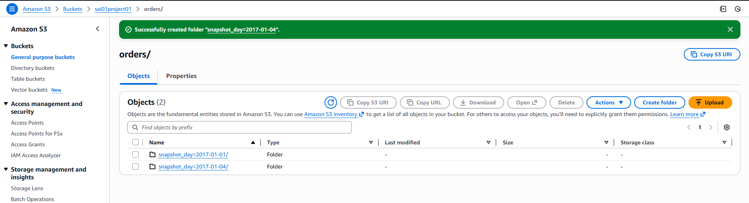

I uploaded my csv file in the folder

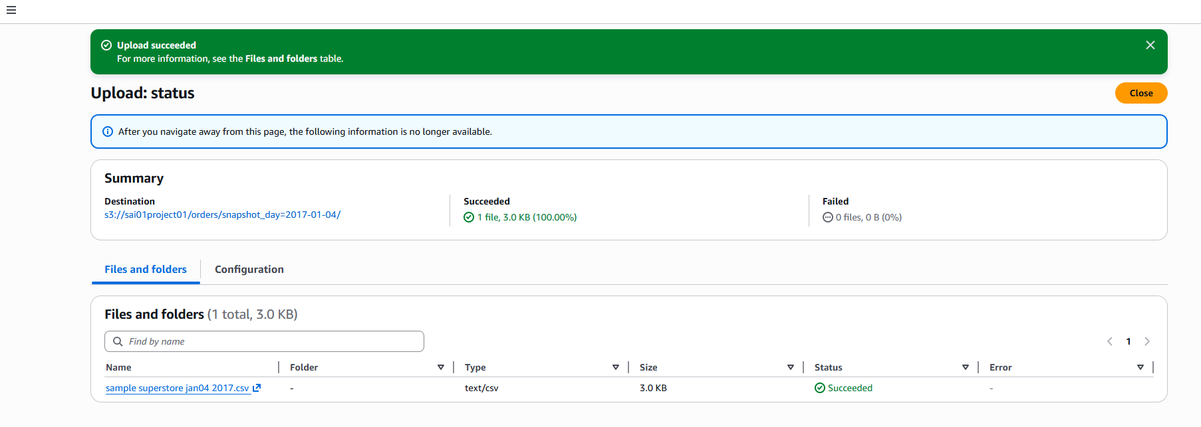

Note: u can add multiple files in it, np

Now let us run the crawler in glue as shown

Click run

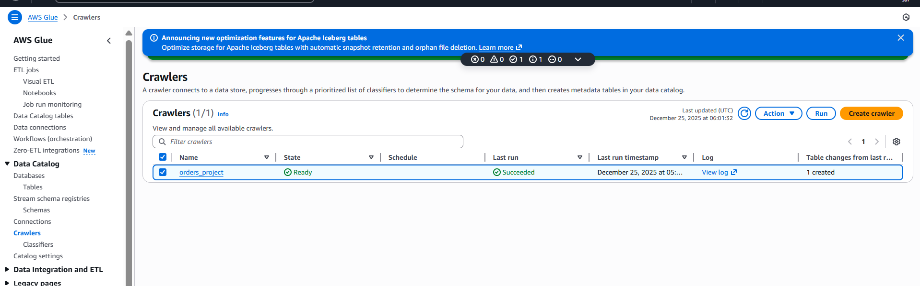

If u click on the crawler, u see the status and shows u all the run

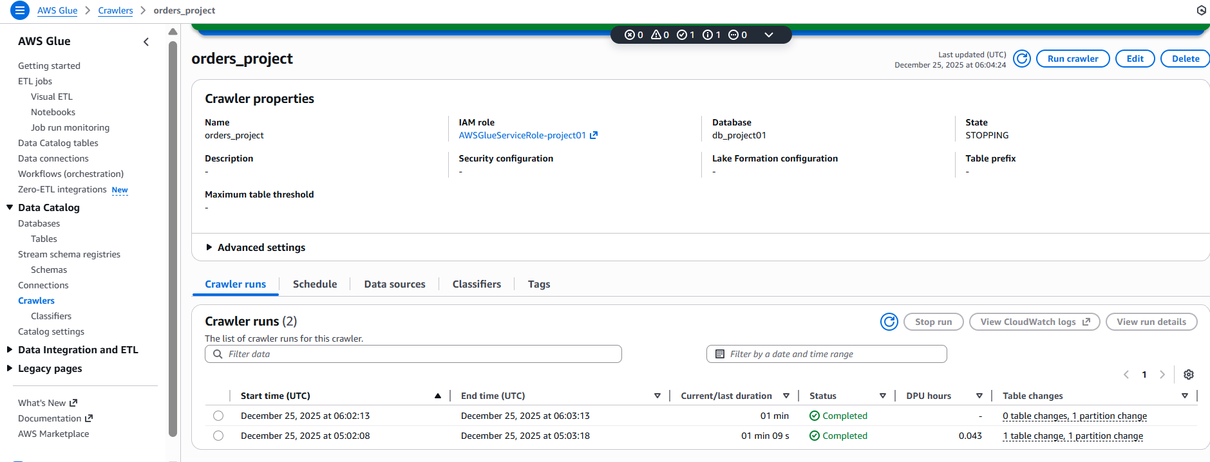

Now we are running on demand but in production u set a schedule,as ur files are coming daily overnight. Next day if u schedule at 5 am what ever the new folders had created it will crawl

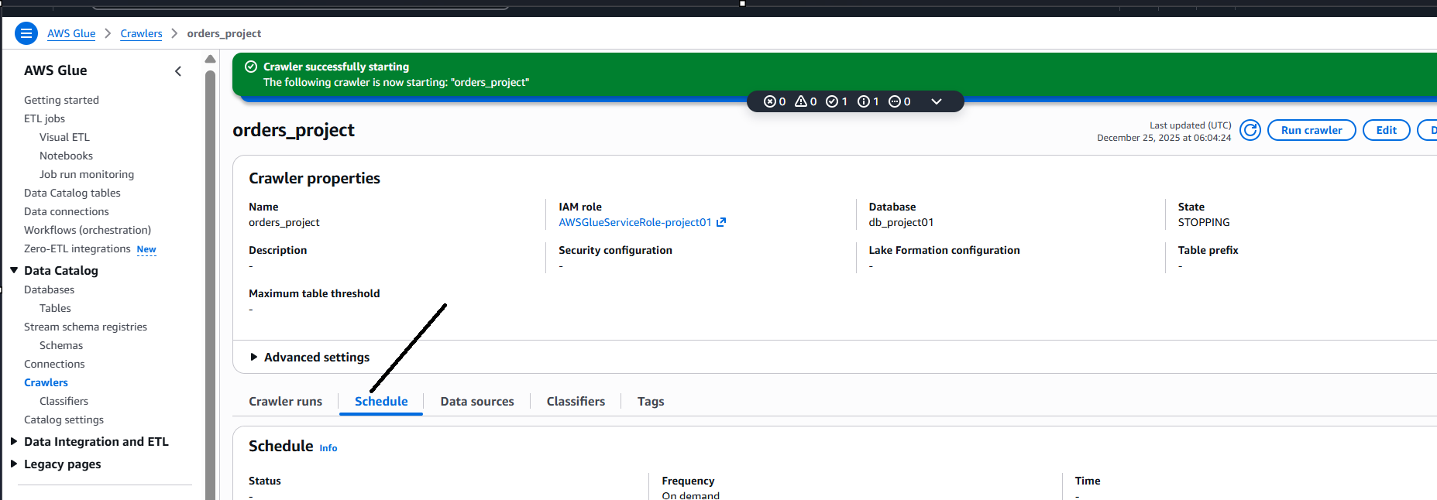

While creating crawler, we had chosen crawl only new subfolders instead of crawl all folders

Now let us go to tables, u see another partition added as shown

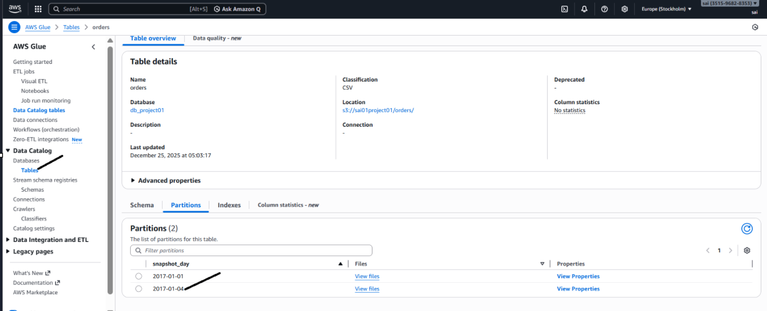

Lets say if my s3 folder is not given in the format snapshot like may be with only date, now u see it creates partition name with some random name eg: partition key

So its better to follow the format but u can follow anything as per wish

Now these partition will help us in running the queries faster as below

Conclusion: the data catelog has all the information of all the folders in the s3 location (orders)

Lets go to athena, click on query editor

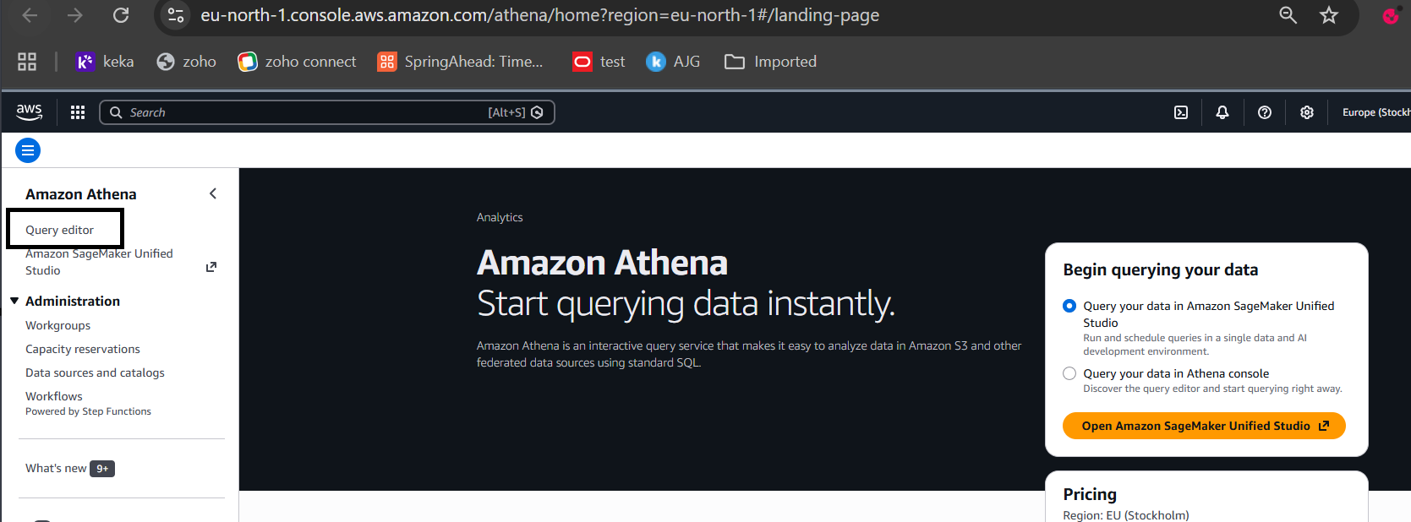

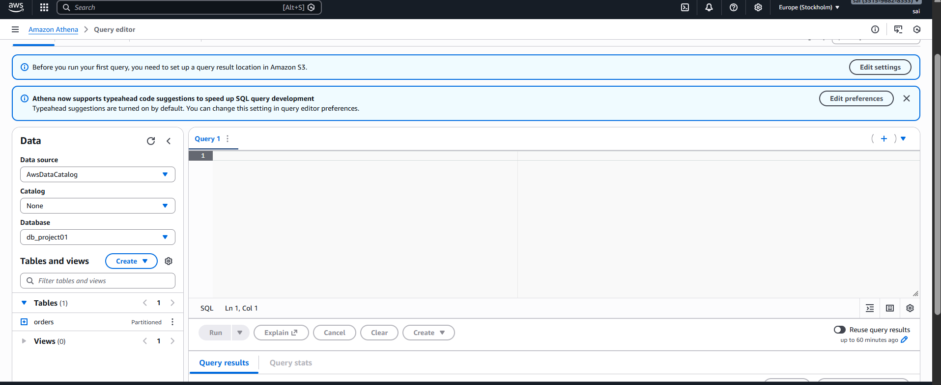

Data source:

U see AwsDataCatalog means datacatalog that I created using glue

U know ur database which u created

It is also showing orders table that we created, it shows it is a partitioned table

It s all the data types

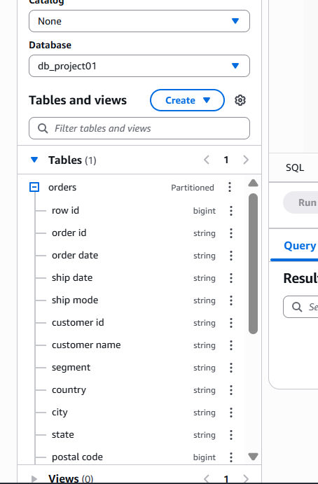

It has snapshot day column as well

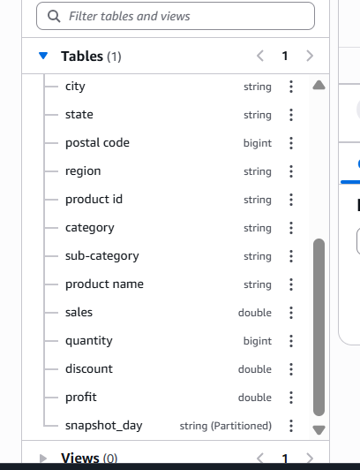

Click on preview table

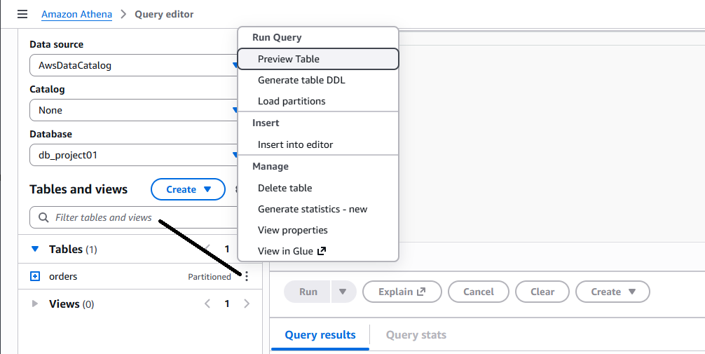

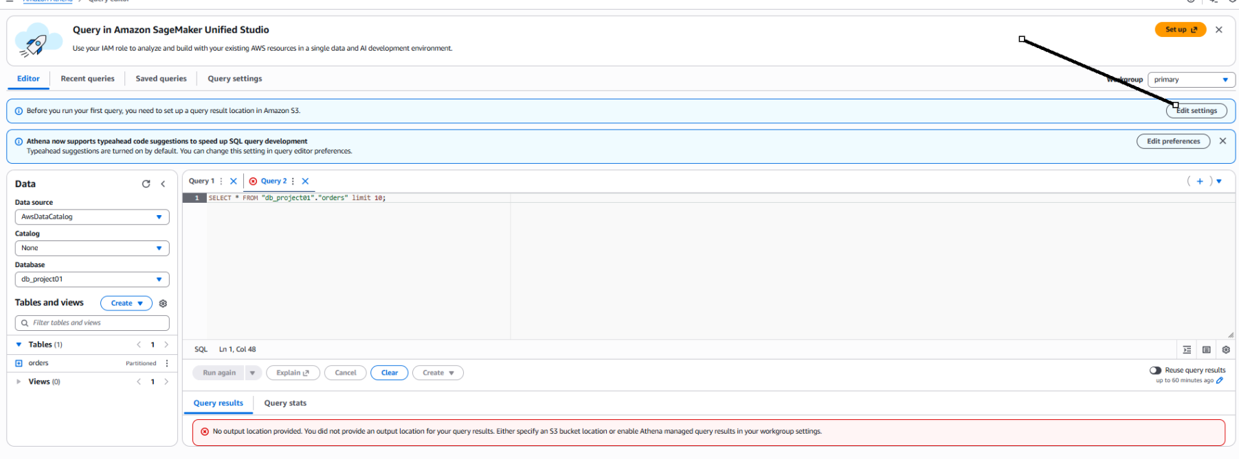

When athena runs, it stores results and that location u need to provide by above

Click on query settings beside saved queries, click on manage

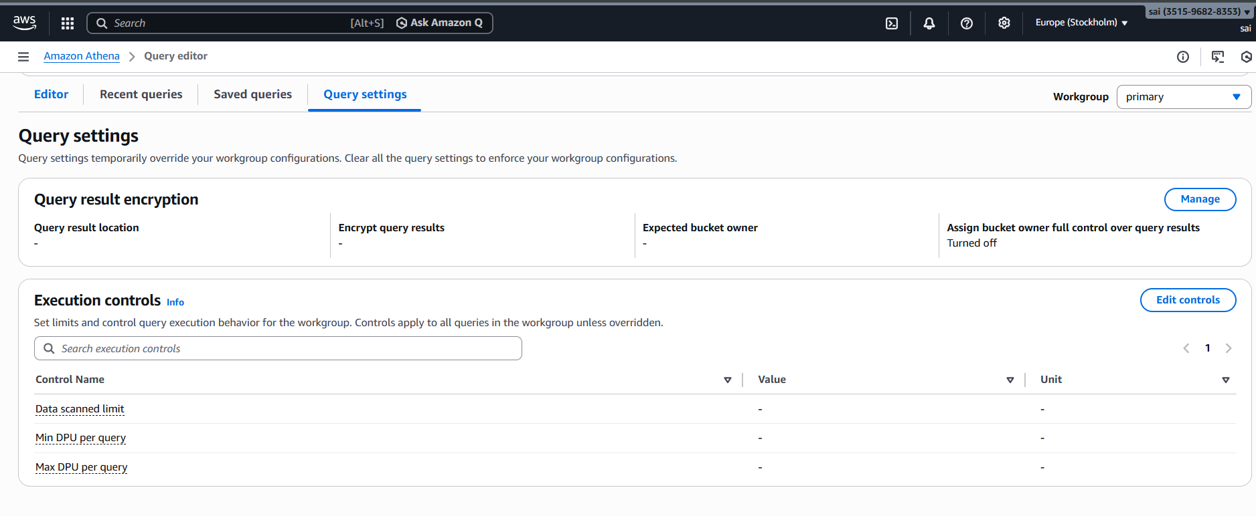

Before that we created a folder as shown

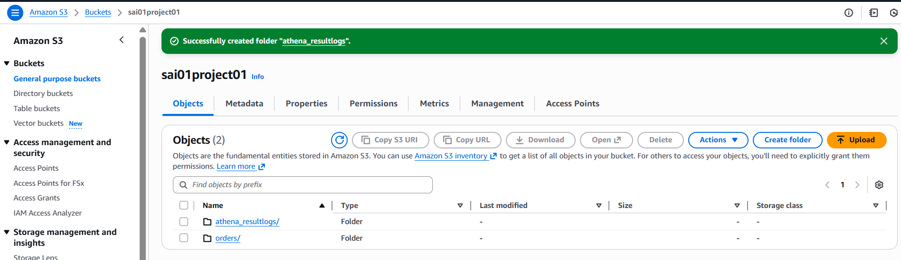

Now specify this location

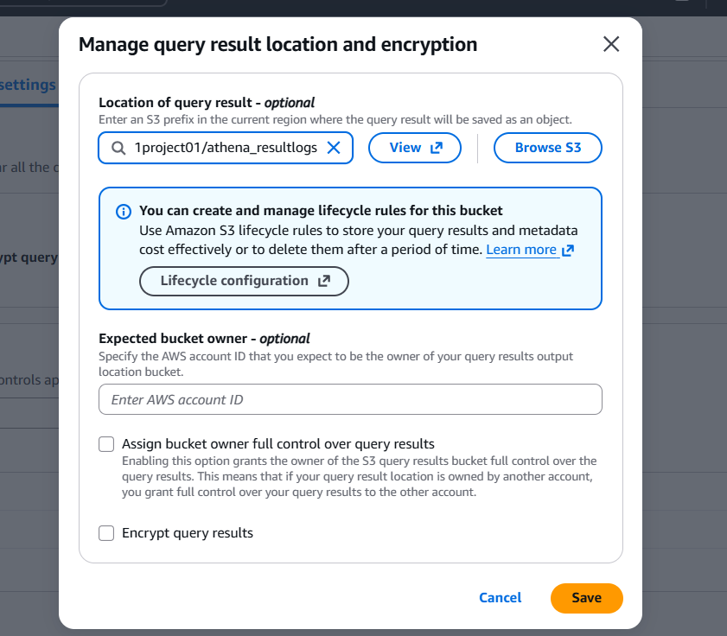

Save

Lets go back to editor and run query

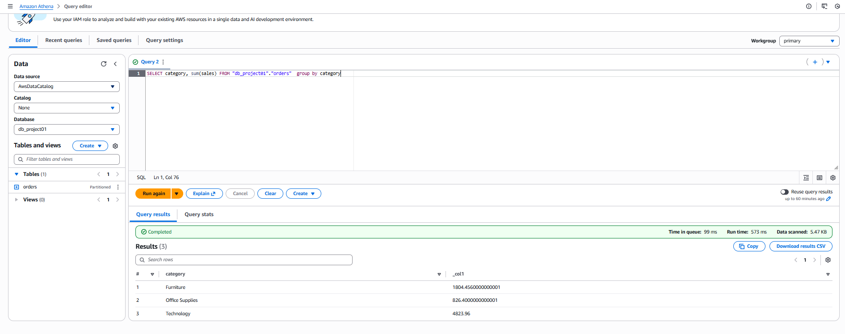

Lets see how how partitions help us

If u see above data scanned is 5.47kb

Lets run whole query

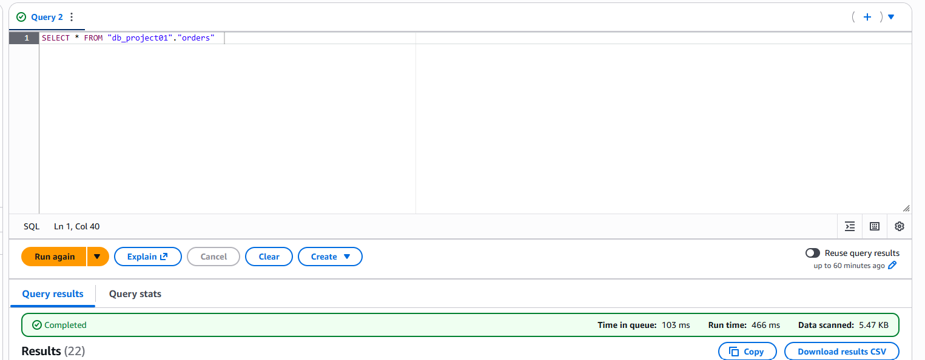

U see the data scanned is 5.47kb, it is scanning all the folders

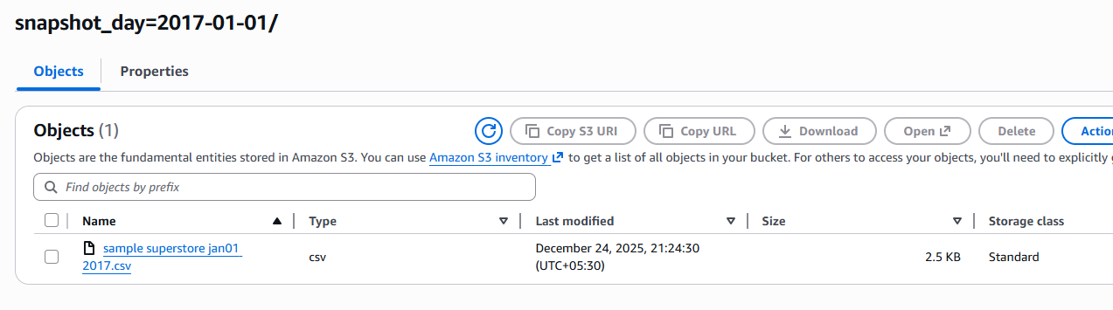

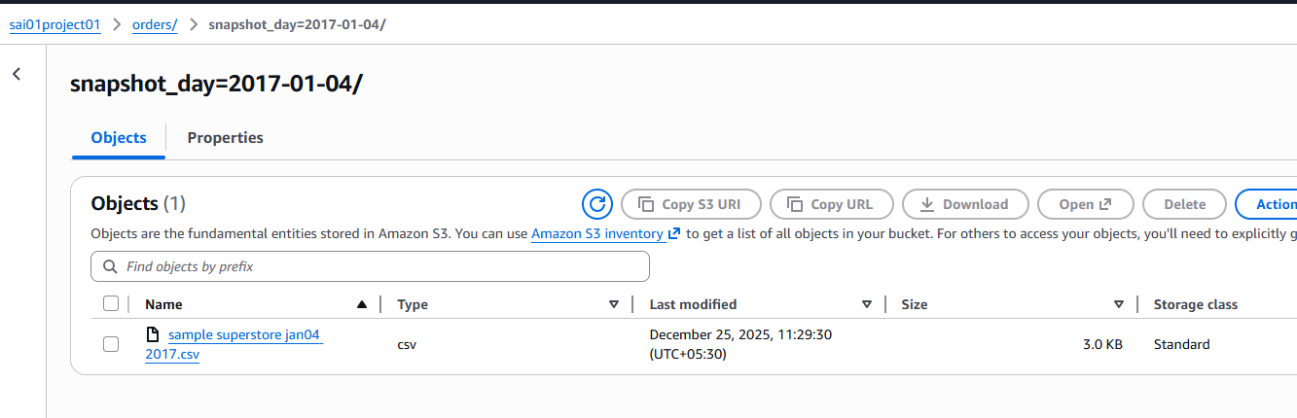

So total 2.5+3 = 5.5kb

When u query with filter as shown, u see it scanned only particular folder which is 2.52kb as per filter

In this way u can reduce scan so that it reduces ur cost and time

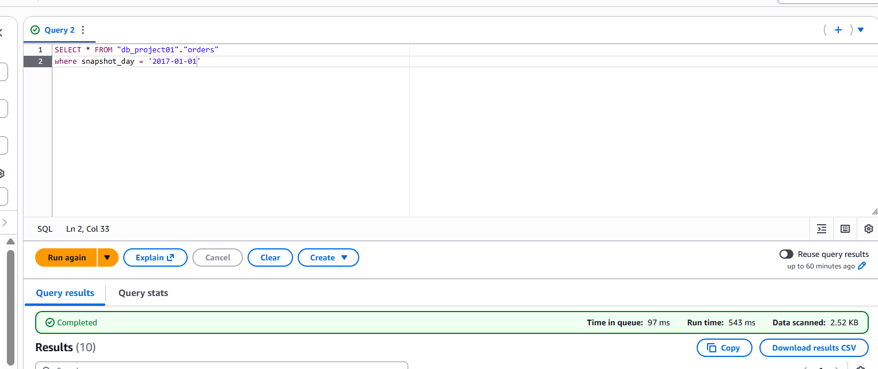

So once u created partitions, it knows where to go exactly

So try to create snapshot folders in s3 like what type of analysis u r going to do

And hence while querying u can save time and cost

Lets go to quicksight

1 month free access by logging with ur email id

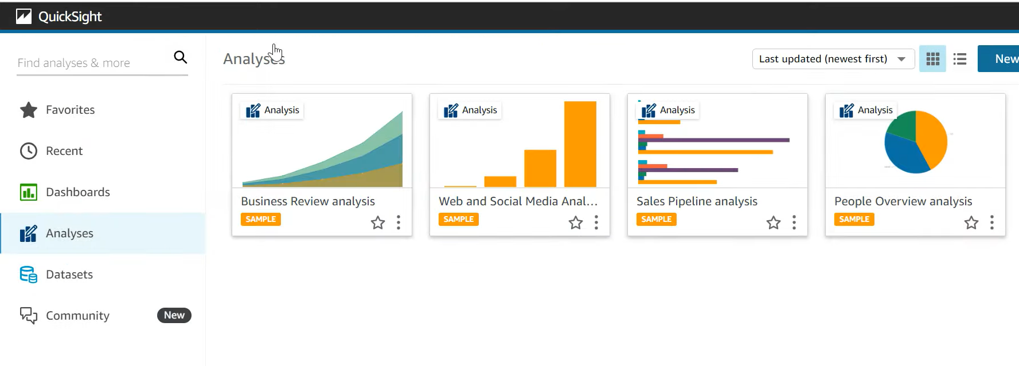

Click on dataset, click new dataset

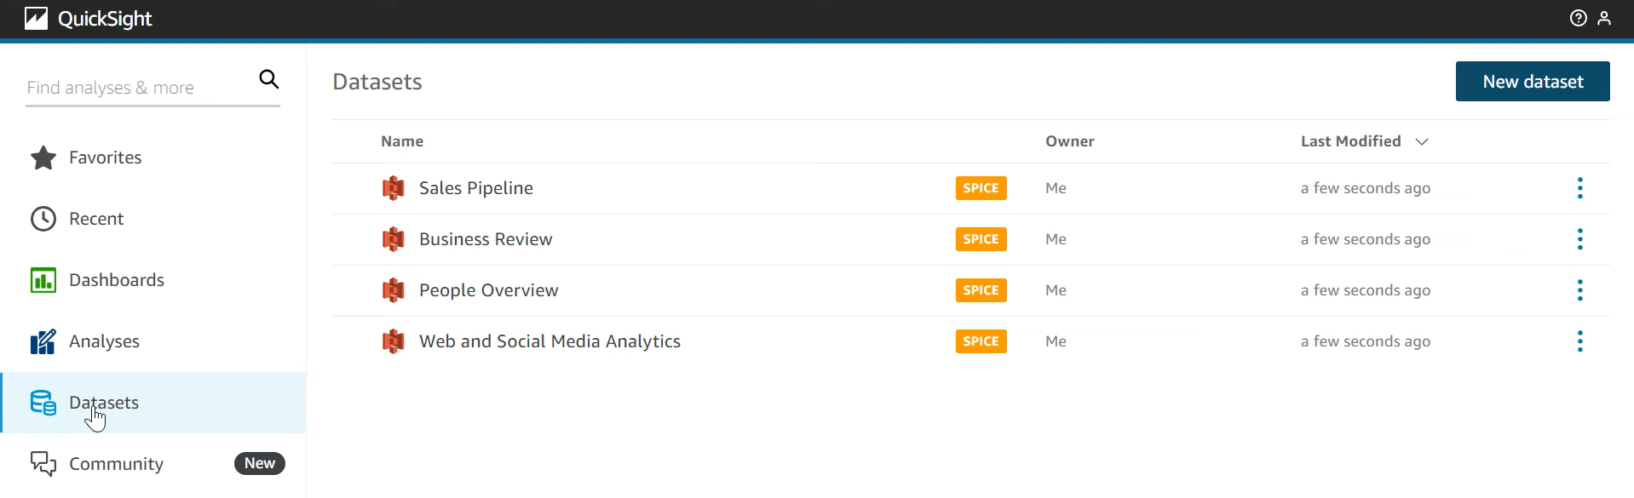

Click on athena

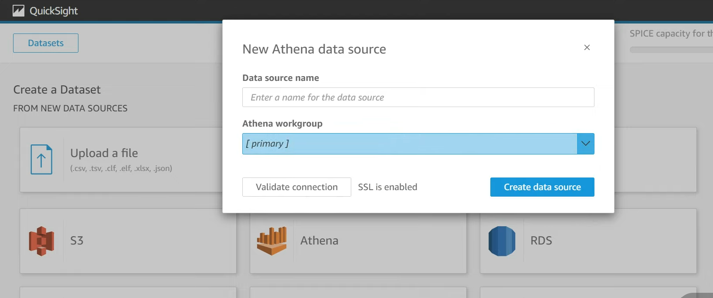

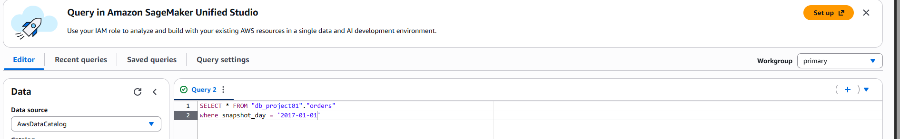

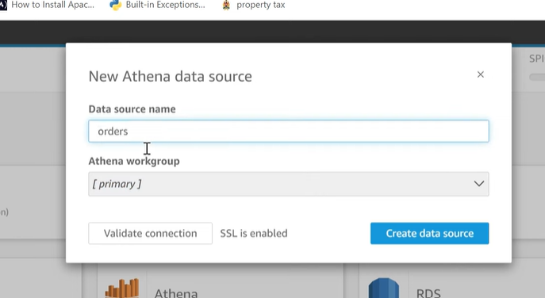

Click validate connection

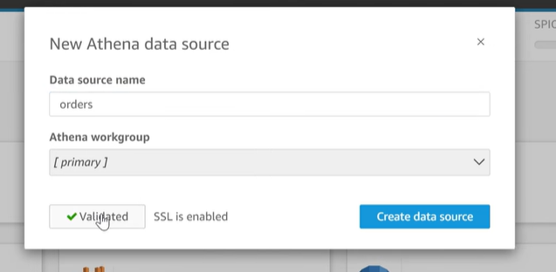

Click create data source

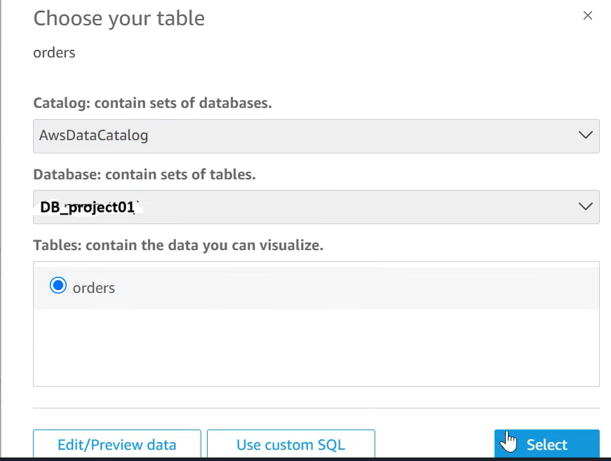

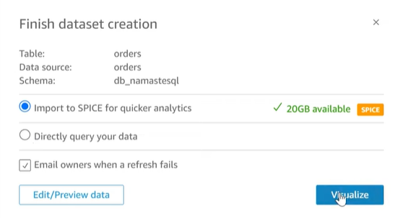

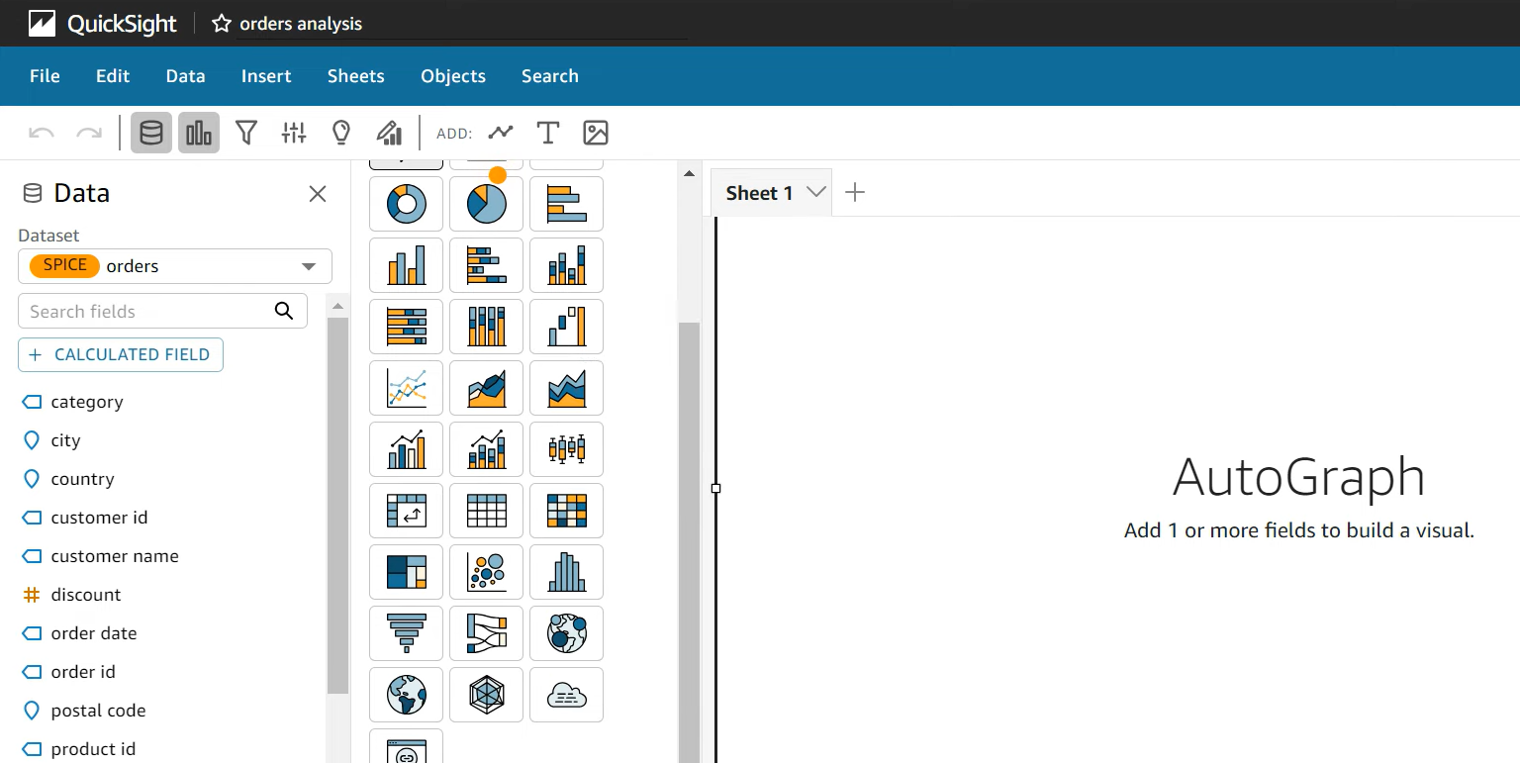

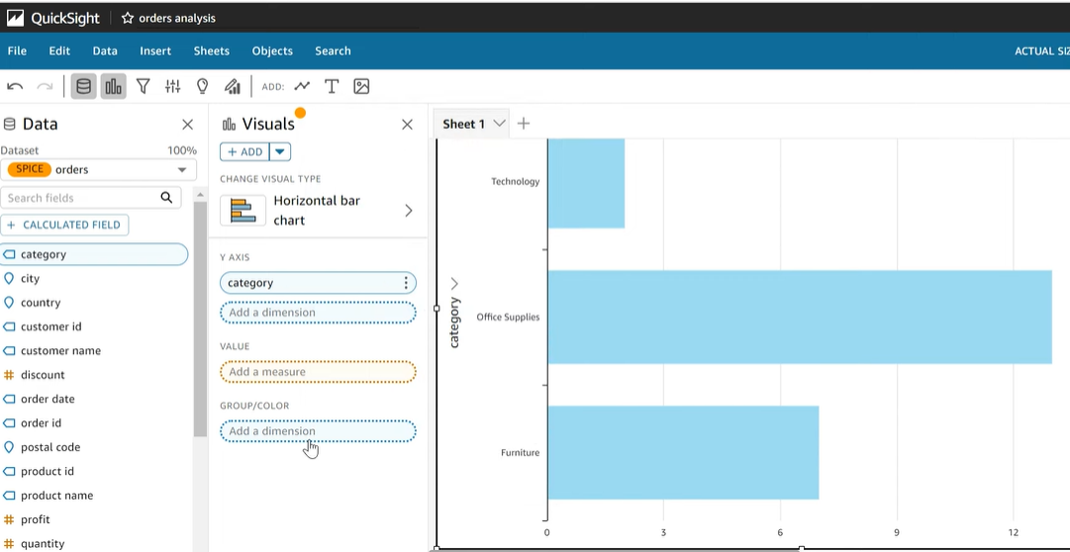

Click on horizontal bar chart,

Y axis: drag category on to y axis

Sales into value

You see the graph as above

If u r unable to do the above, give access as shown

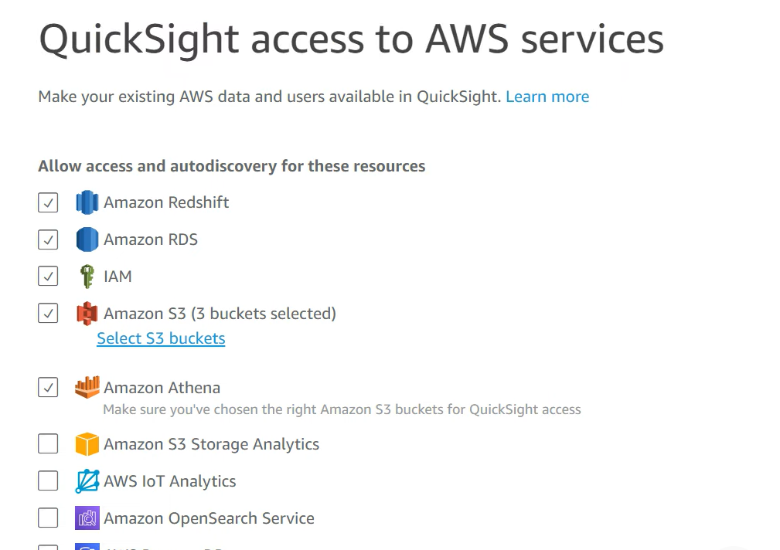

Now publish

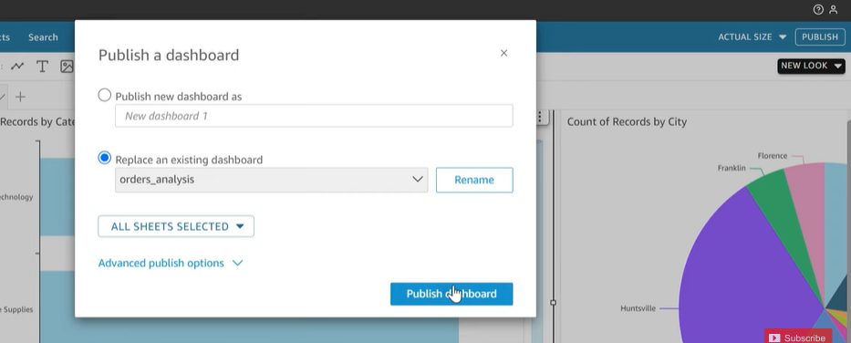

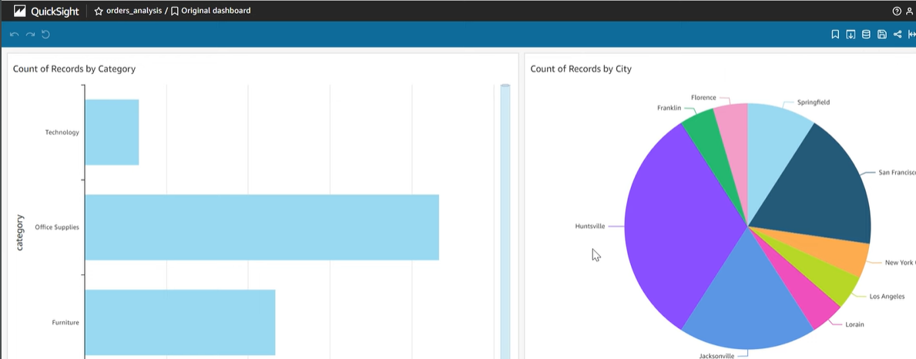

Finally, I don’t need to store data in some db and for quick analysis I uploaded files in s3, run a crawler, run the queries on it in athena and create charts